**PREFACE**

* This project is developed for submission of Bachelor of Computer Application course. This project provides user the facility to Purchase Car Accecories online
* In the making of this Website we used SQL Server as backend-end tool, And ASP.Net as front-end tool. SQL Server is globally known for being the most secure and reliable database management system.
* As a student of BCA, we get opportunity to develop a Website for our 6th semester project.
* It also includes a dissertation to be submitted by each of the BCA student as a part of the curriculum.
* This project report is submitted as a part of the three years course of BCA
* BCA-VI conducted by Bachelor of Computer Application from

Saurashtra University, Rajkot.

**ACKNOWLEDGEMENT**

* It is our pleasure to acknowledge you that we have taken a project on Online Car Accessories Product Shopping Site.
* We are thankful to our Prof. Piyush D. Pitroda for giving us full guidance and co-operation in understanding the information system. We also thank them for their unconditional help in making of this project.
* We are also thankful to our family and friends for supporting us in every situation.
* Finally, we want to say thanks to all faculties of National Computer College for helping us a lot.

**SHIKHALIYA PRATIK**

**JATIYA DHARMIK**

**SAURASHTRA UNIVERSITY**

The Saurashtra University is one of the most well-known universities.

It was established on 23rdmay, 1968. It was fairly reputed university in India conducting various courses regarding the dream of 21st century. The university in going day by day, this provides the student the courses level from the graduate to PH.D.

Shree Haribhai Trivedi and Shree Dolarbhai Mankad printthe title magazine in 1958 the resolution passed and 16 August, 1960.It was accepted in the 3rd five year plan of Gujarat, which is started in 1961-62. In 1965 December, the rules regarding university got the permission and 23 august, 1966 certain section is implementedby the result of Saurashtra University started.

The Saurashtra University works officially at 23 may, 1967. At the same time 35 colleges and 2 permitted institutions were started Rajkot, Bhavnagar, Amreli, Junagadh, and Surendranagar districts. The total students were about 18000. Then in the same year two college sare permitted and 37 colleges existed.

**NATIONAL COMPUTER COLLEGE**

**Oppo. 4-Oswal Colony, Sundaram Society, Satyam Colony Road, Jamnagar.**

**Phone no. (0288) 2711338**

National Computer College is begun in year 2000. It is affiliated with Saurashtra University.

Two courses are available in National Computer College. They are Bachelor of Computer College (B.C.A), Bachelor of Business Administration (B.B.A).

As and when we surrounded by difficulties and problems, faculties always guide us and solve our problems. Our principal DR. DIPTI DOMADIYA always inspired us to go ahead though in most difficult situations. The authority persons and all the staff members of National Computer College are good care taking and always helped us in any situation. Each and every subject is explained very easily and in detail so that student can understand very easily and in details so that students can understand very easily. The faculties associated with the college are very helpful &co-operative.

Staff of National Computer College

Principal: Dr. Dipti H. Domadiya

Faculties: Prof. Chirag S. Mehta

Prof. Piyush D. Pitroda

Prof. Rohit J. Pambhar

Prof. Tushar R. Sheth

**ABOUT ORGANIZATION**

The Organization “Autohub Car Decore”, has been established for fulfilment of providing service to each and every client at facility of providing Car Accecories Products & Car Modification Service in Jamnagar since last 5 years.

They are very well service and having a good effort in Car Modification. People trust them for their quality and service.

With dedication and hard work, the Store has established the base of the system in diverse regions of the store. We have a long list of pleased who have helped us to establish a name of repute in this field and sustain it for more than a century.

**System Development Life Cycle**

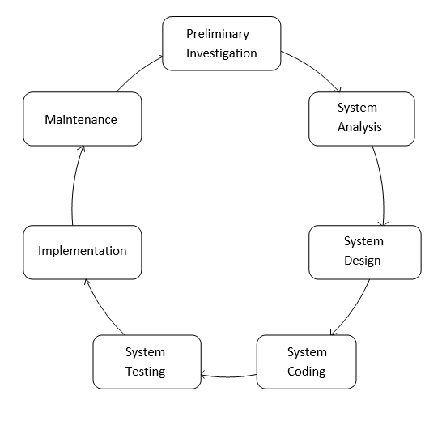

**SOFTWARE USED**

* **Front-end:**
* ASP.NET
* **Back-end:**
* SQL SERVER 2012
* **OS:**
* Windows 7 Ultimate

**ABOUT .NET FRAMEWORK**

* **Introduction**

.Net is a new platform developed by Microsoft. It is a development infrastructure with a new programming interface to windows services and APIs, integrating a number of technologies.

The .Net platform has several components such as servers like BizTalk and SQL server, as well as services as .Net my services and its first visible components, .Net passport, is being described by some as integral parts of the .Net platform. But its main component is the .Net framework. It includes Visual Studio .Net (VS.NET), the .Net Common Language Runtime (CLR), and the .Net Base Class Library (BCL).

The other components may be required by specific application, but they are not a necessary part of all .Net application.

* **The .Net Framework**

1. **Several .NET Production**

Various applications from Microsoft Based on the .NET Framework, including new version of exchange and SQL server, which are Extensible Markup Language (XML) enable and integrated into the .NET platform.

1. **Several .Net Services**

Provided by Microsoft for use in developing applications running under the .NET framework. .Net framework itself can be divided into two parts: -

1. The CLR (Common Language Runtime): -

A managed execution environment that handles memory allocation, error trapping and interacting with the operating system services.

1. The BCL (Base Class Library): -

An extensive collection of programming components and Application Program Interfaces (APIs).

**.NET FRAMEWROK ARCHITECTURE**

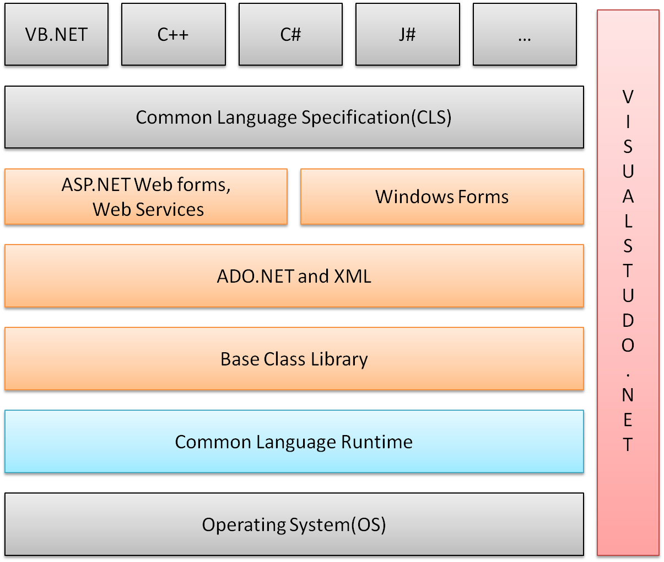

* **Feature of .Net Framework: -**

1. **Multi-language Development**

Net provides the user a set of different languages like create an application like C#, VB.NET, C++ etc. all the languages are integrated with each other through MSIL.

1. **Platform and Processor Independent**

The code written using .NET platform is independent of CPU or processor. It can work on different kind of processor perfectly well. The code written in .NET platform Is also platform independent because when a code is written language such as C# or VB.NET?

1. **Automatic Memory Management**

Automatic memory management is one of the services that the Common Language Runtime (CLR) provides. CLR garbage collector manages the allocation and released of memory for an application.

1. **Easy Deployement**

As deployment is a routine task today, .NET platform provides easy to ways f deployment as it platform and processor independent.

* **Security**

As application are extended to the internet, new risks are extended to the organization that deploy these applications. To solve this, .NET provides a number of security features.

**ABOUT SQL SERVER**

* **What is SQL SERVER?**

SQL SERVER is SQL (Structured Query Language) Database server. SQL is the most popular database language in the world. SQL SERVER is client server implementations that consist of a server demon SQL SERVER and many different client programs / libraries. The main goals of SQL SERVER are speed and robustness.

The base upon which SQL SERVER is built is a set of routines that have been used in a highly demanding production environment for many years. While SQL SERVER is activity developed, it already offers a rich and highly useful function set.

* **The Main Features of SQL SERVER:-**

Fully multi-threaded using kernel threads. That Means that it easily can multiple CPU if available.

* Work on a lot of different platforms
* SQL function are implemented thought a very optimize class library and should be as fast as they can get! Usually there shouldn’t be any memory allocation at all after the query initialization.

A privilege and password system with is very flexible and secure password since all password traffic on the net encrypted.

**Data FlowDiagram**

* **Zero Level DFD(Context Level)**

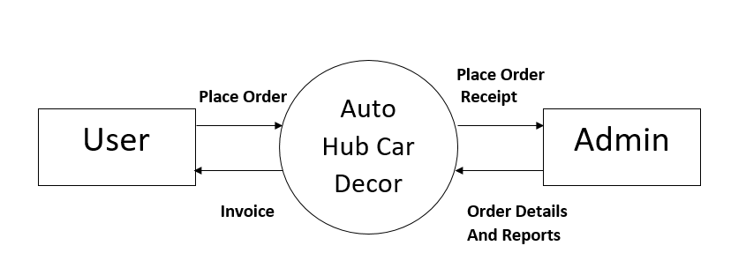

* **1stLevel DFD**

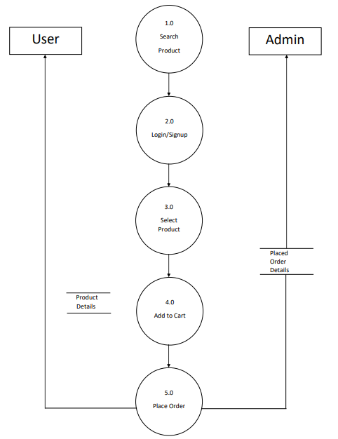

**Data Dictionary**

**tbl_admin:**

|  |  |  |
| --- | --- | --- |
| Field | Type | Key Attributes |
| a_id | Numeric(18,0) | Primary Key |
| a_email | varchar(50) | - |
| a_password | varchar(50) | - |

**tbl_cart:**

|  |  |  |
| --- | --- | --- |
| Fields | Type | Key Attributes |
| c_id | numeric(18, 0) | Primary Key |
| c_user_id | numeric(18, 0) | - |
| c_pro_id | numeric(18, 0) | - |
| c_qty | numeric(18, 0) | - |

**tbl_category:**

|  |  |  |
| --- | --- | --- |
| Field | Type | Key Attributes |
| cat_id | numeric(18, 0) | Primary Key |
| cat_name | varchar(50) | - |

**tbl_feedback:**

|  |  |  |
| --- | --- | --- |
| Field | Type | Key Attributes |
| id | numeric(18, 0) | Primary Key |
| name | varchar(50) | - |
| email | varchar(50) | - |
| subject | varchar(50) | - |
| comment | text | - |

**tbl_order:**

|  |  |  |
| --- | --- | --- |
| Fields | Type | Key Attributes |
| o_id | numeric(18, 0) | Primary Key |
| o_user_id | numeric(18, 0) | - |
| o_name | varchar(50) | - |
| o_email | varchar(50) | - |
| o_phone | varchar(10) | - |
| o_address | text | - |
| o_amount | numeric(18, 0) | - |
| o_date | date | - |

**tbl_order_item:**

|  |  |  |
| --- | --- | --- |
| Fields | Type | Key Attributes |
| oi_id | numeric(18, 0) | Primary Key |
| oi_order_id | numeric(18, 0) | - |
| oi_pro_id | numeric(18, 0) | - |
| oi_pname | varchar(50) | - |
| oi_price | numeric(18, 0) | - |
| oi_qty | numeric(18, 0) | - |
| oi_amount | numeric(18, 0) | - |

**tbl_product:**

|  |  |  |
| --- | --- | --- |
| Field | Type | Key Attributes |
| pro_id | numeric(18, 0) | Primary Key |
| pro_cat_id | numeric(18, 0) | - |
| pro_name | varchar(50) | - |
| pro_price | numeric(18, 0) | - |
| pro_image | text | - |
| pro_description | text | - |
| pro_stock | numeric(18, 0) | - |

**tbl_user:**

|  |  |  |
| --- | --- | --- |
| Field | Type | Key Attributes |
| user_id | numeric(18, 0) | Primary Key |
| user_name | varchar(50) | - |
| user_email | varchar(50) | - |
| user_phone | varchar(10) | - |
| user_address | text | - |
| user_password | varchar(50) | - |

**Validation & Security**

* **Validations:**
  + The Password should contain only characters and numbers.User can’t include special characters.
  + For login into website users must have fill all the details.Because all the fills are mandatory.
* **Security:**
* Security is one of the special features of our website.
* Website will not allow you to access and of the administrative tools until you provide valid username and password.

**Site Map**

**Snapshots User site**

**Home.aspx **

**About.aspx**



**Product.aspx**



**Product_details.aspx**

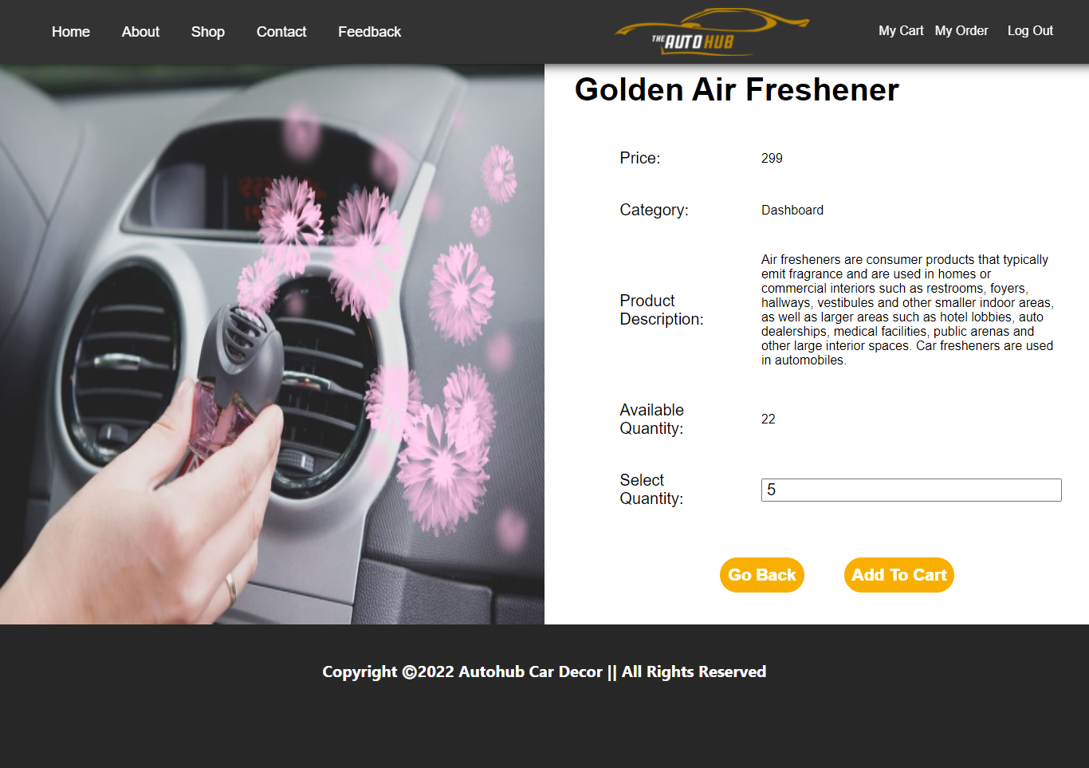

**Contact.aspx**

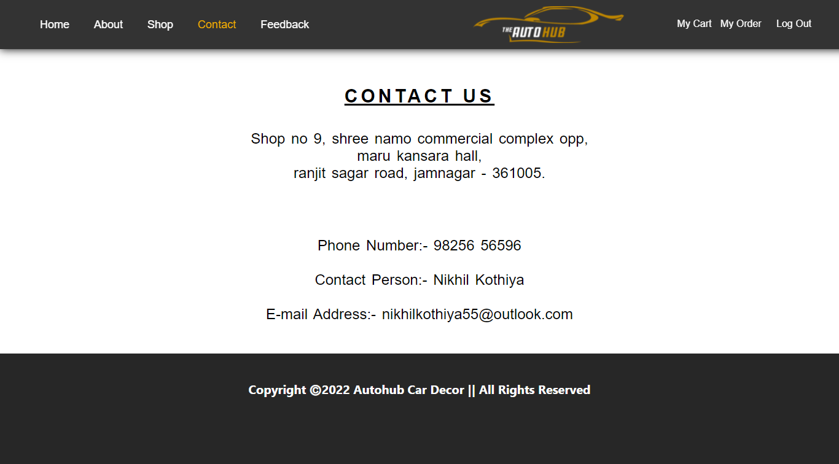

**Feedback.aspx**

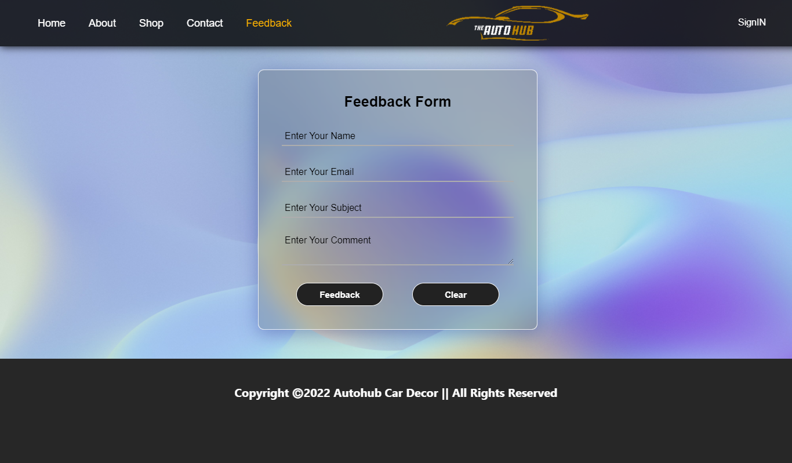

**Cart.aspx**

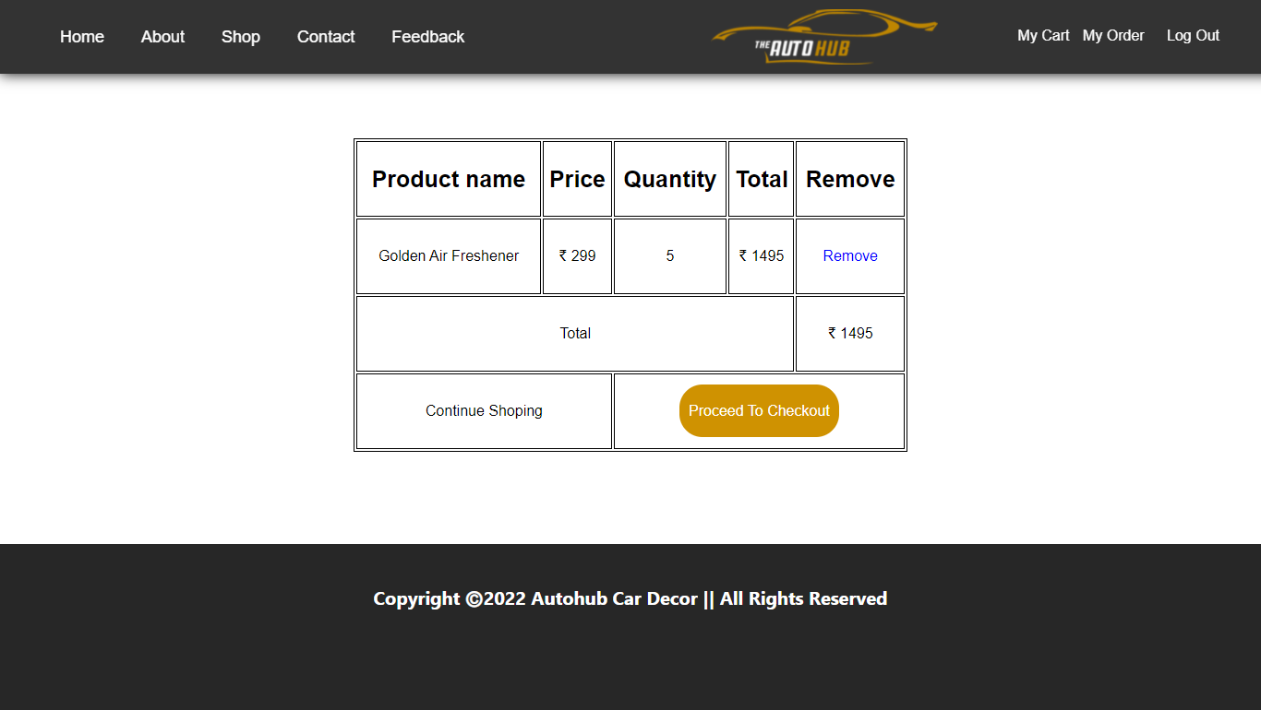

**Proceed_to_checkout.aspx**

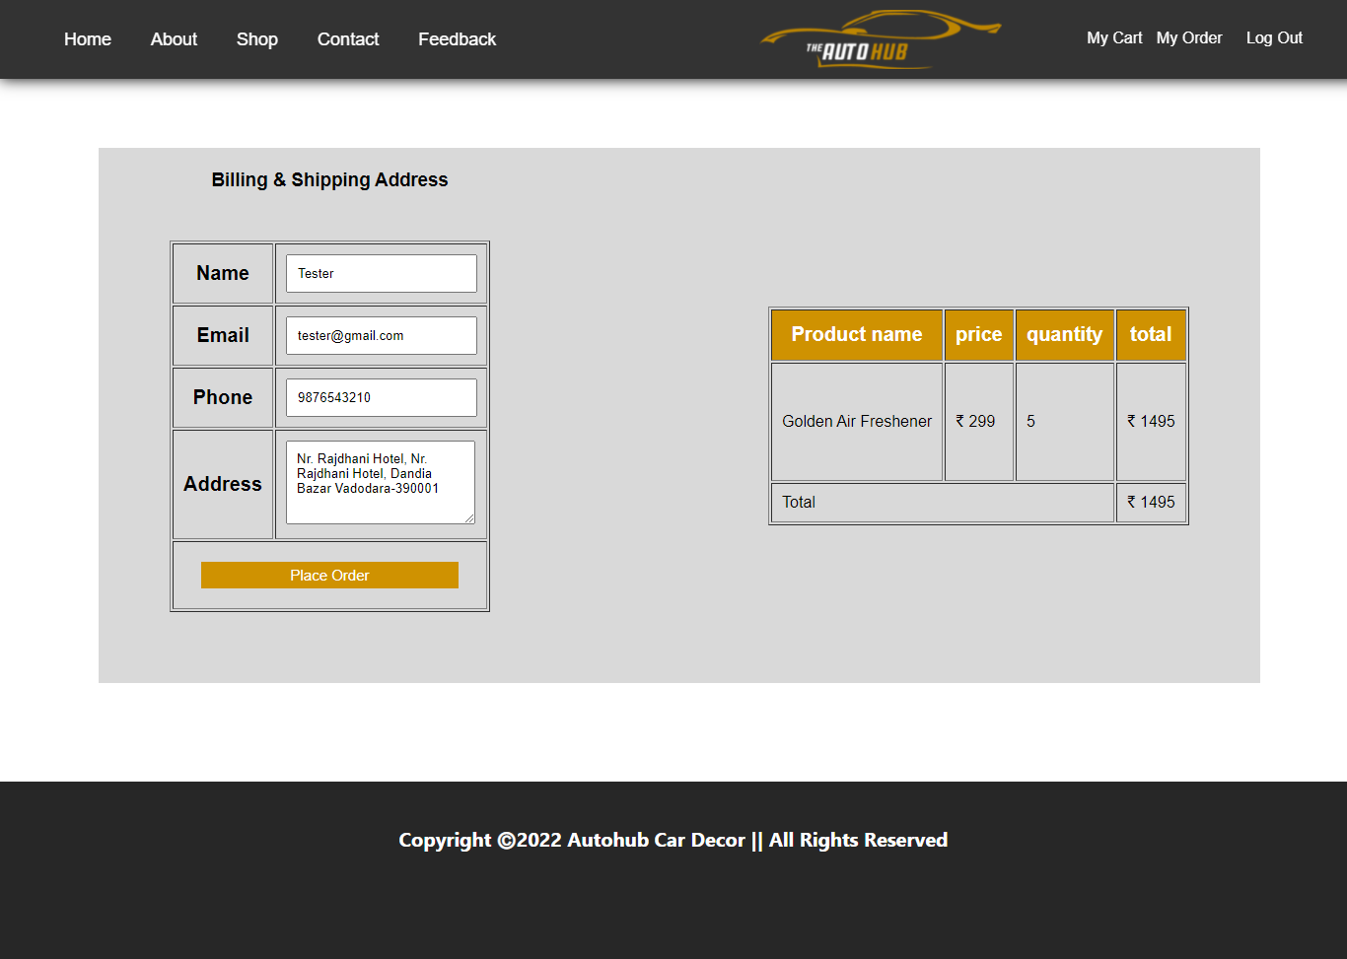

**Order.aspx**

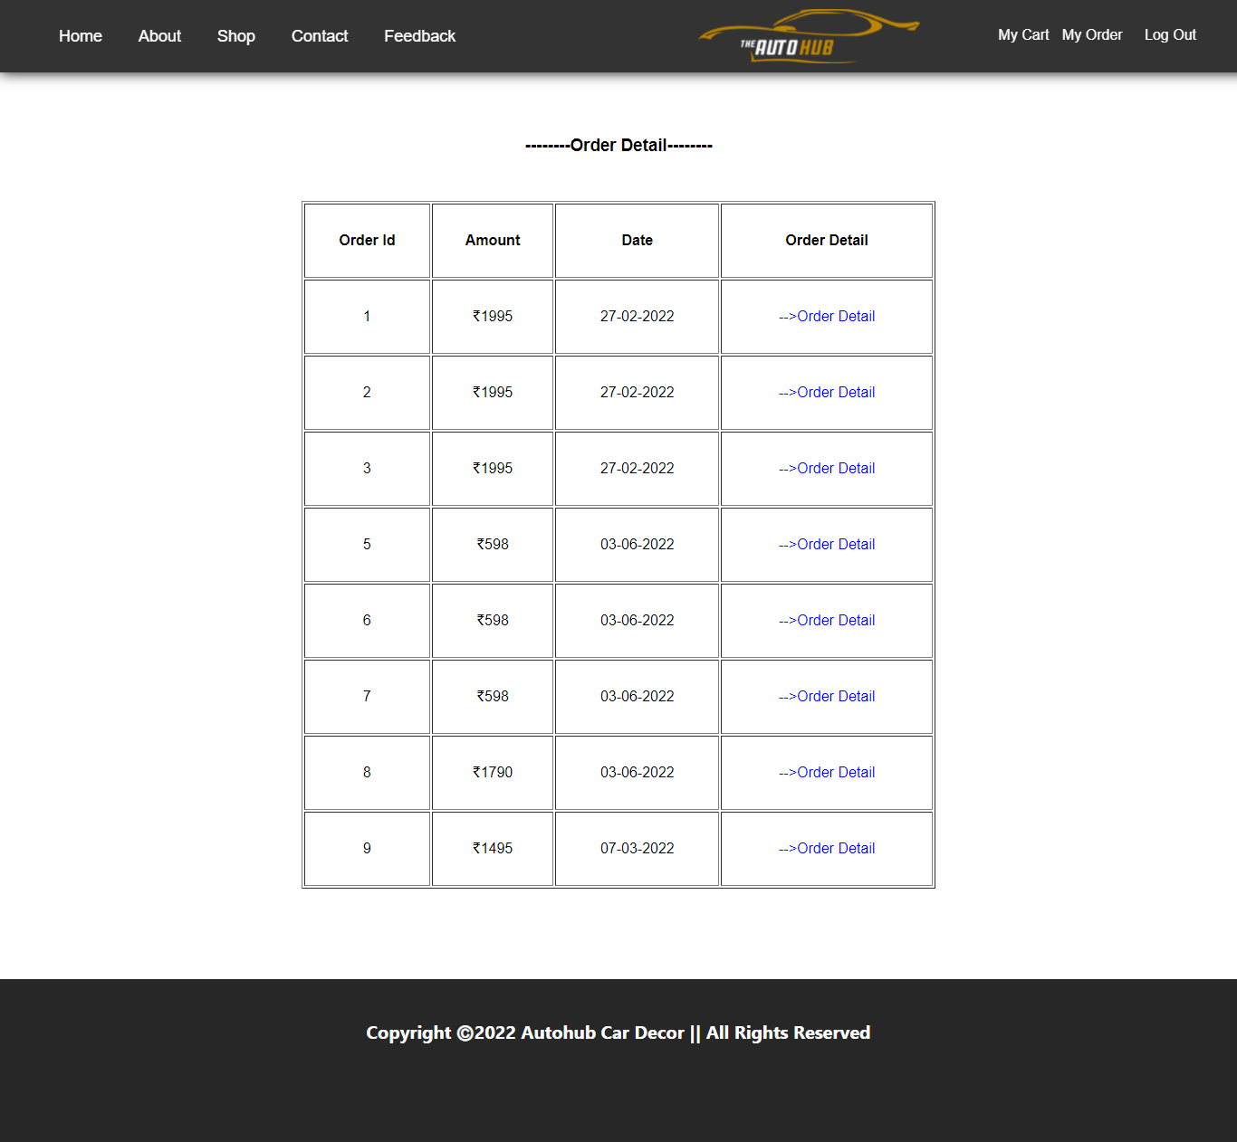

**Order_details.aspx**

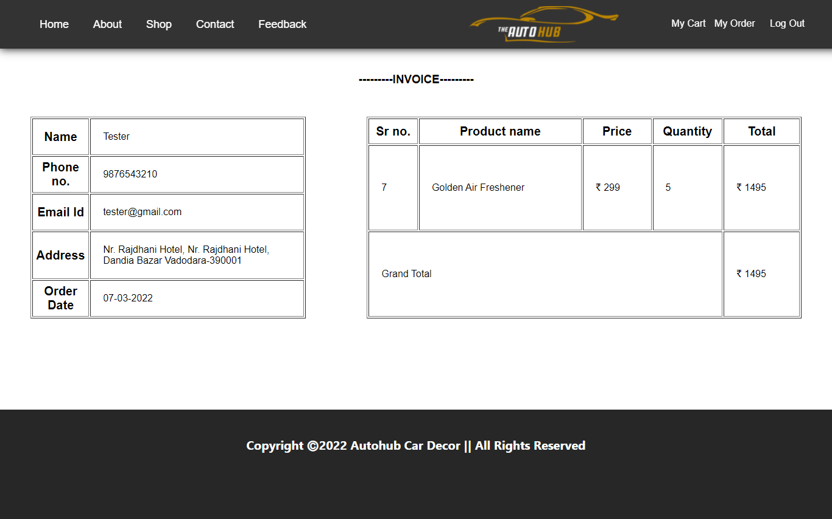

**Sign-in.aspx**

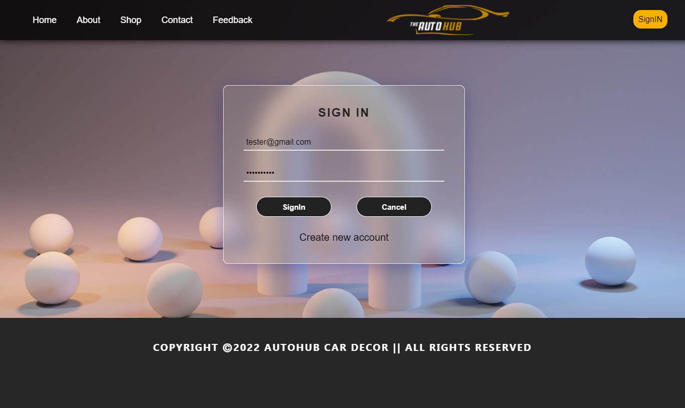

**Sign-up.aspx**

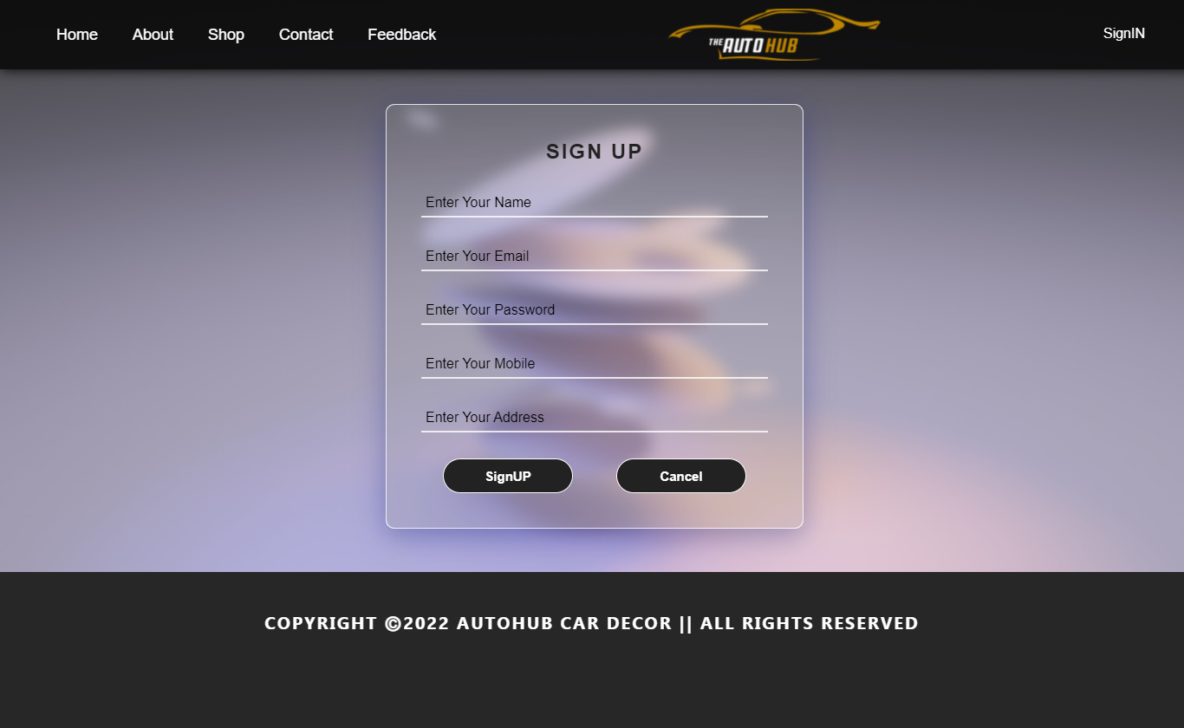

**Snapshots Admin site**

**Admin_login.aspx**

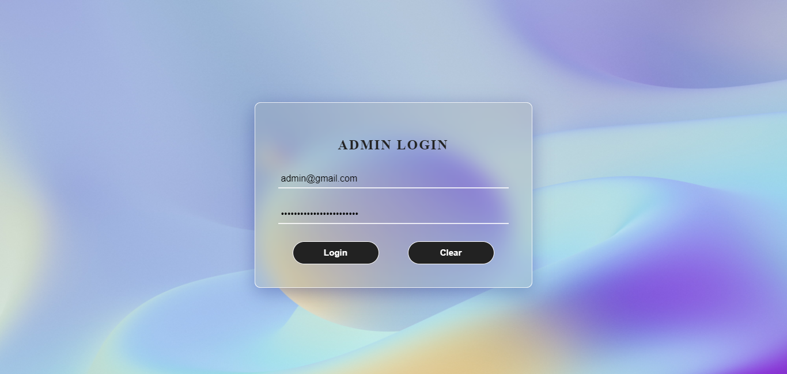

**Admin_home.aspx**

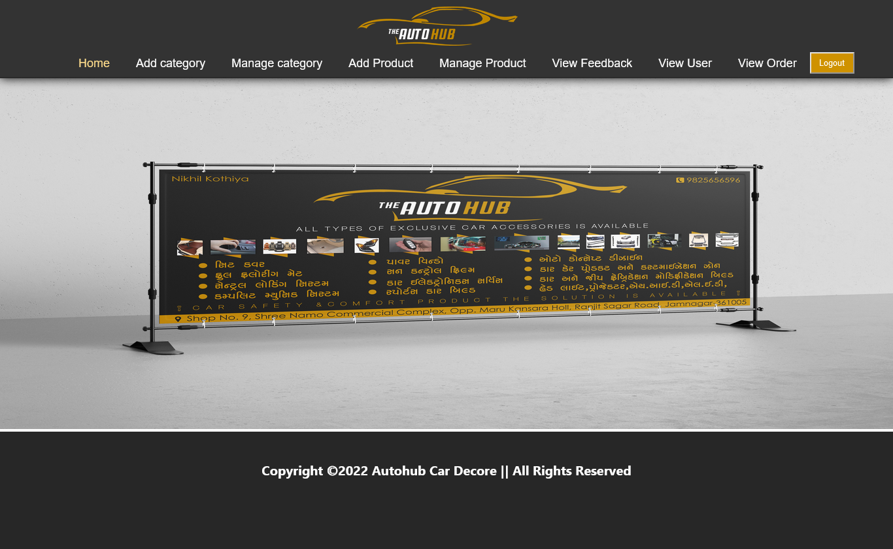

**Add_category.aspx**

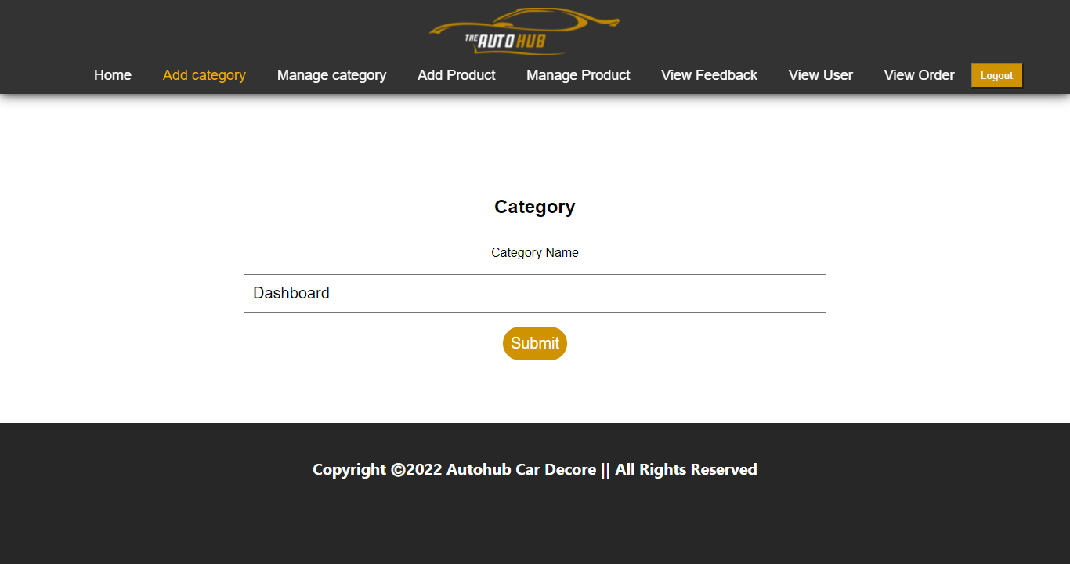

**Manage_category.aspx**

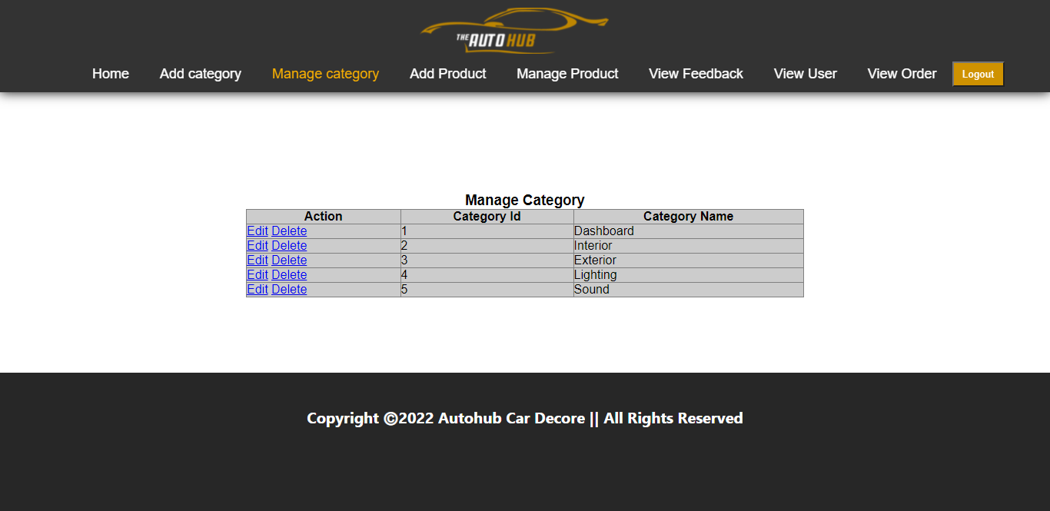

**Add_product.aspx**

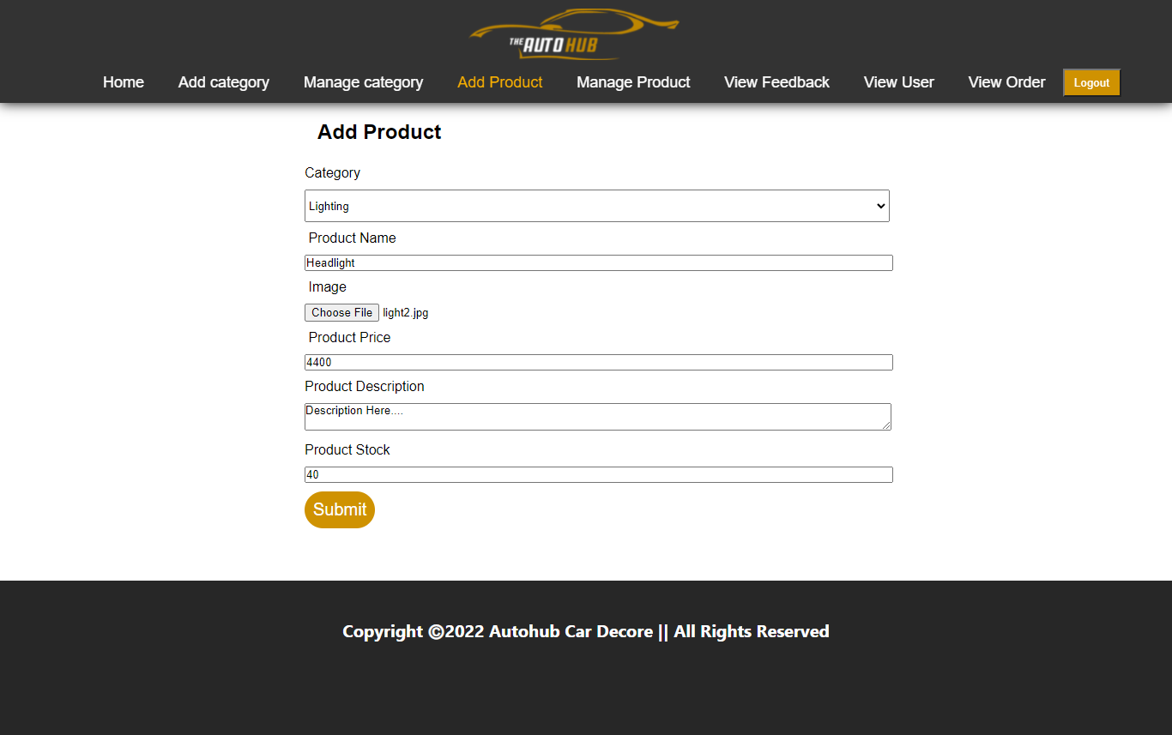

**Manage_product.aspx**

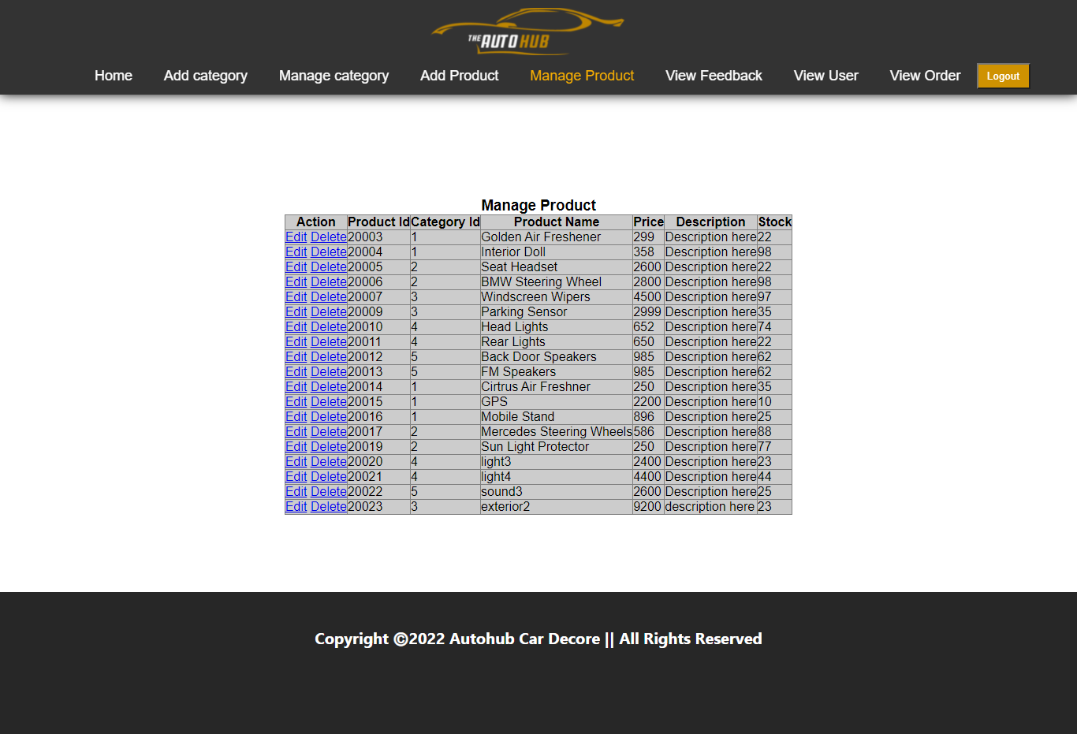

**View_feedback.aspx**

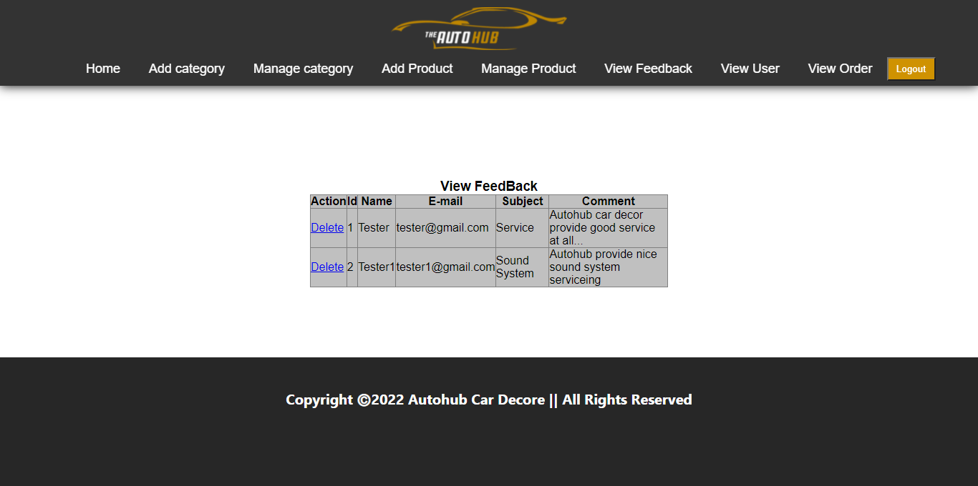

**View_user.aspx**

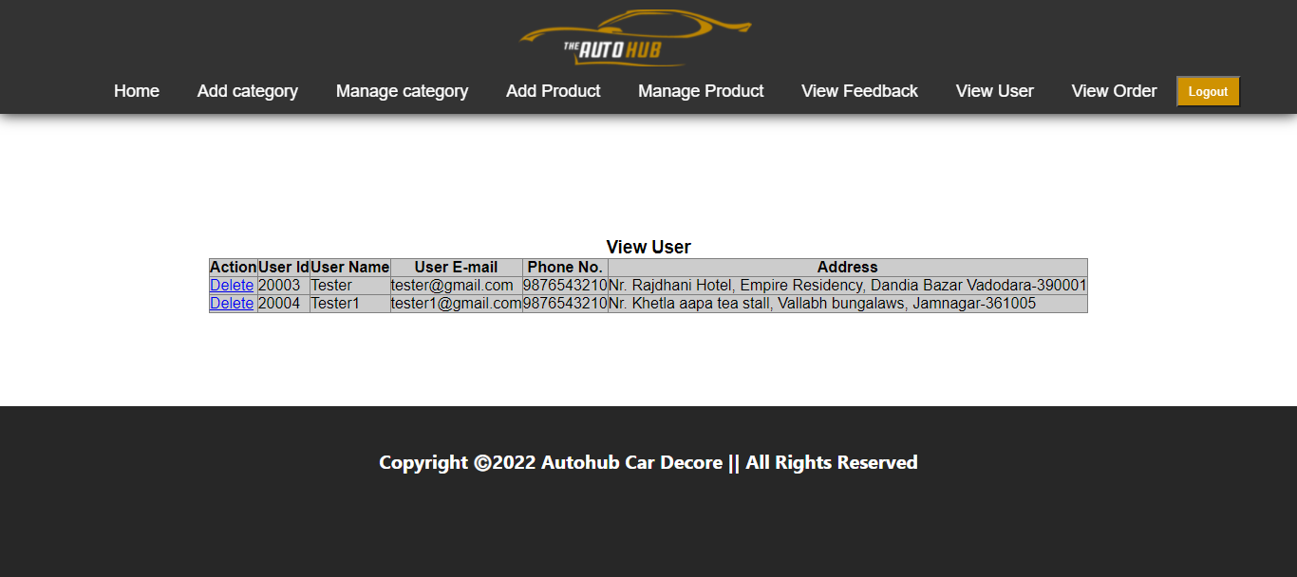

**View_order.aspx**

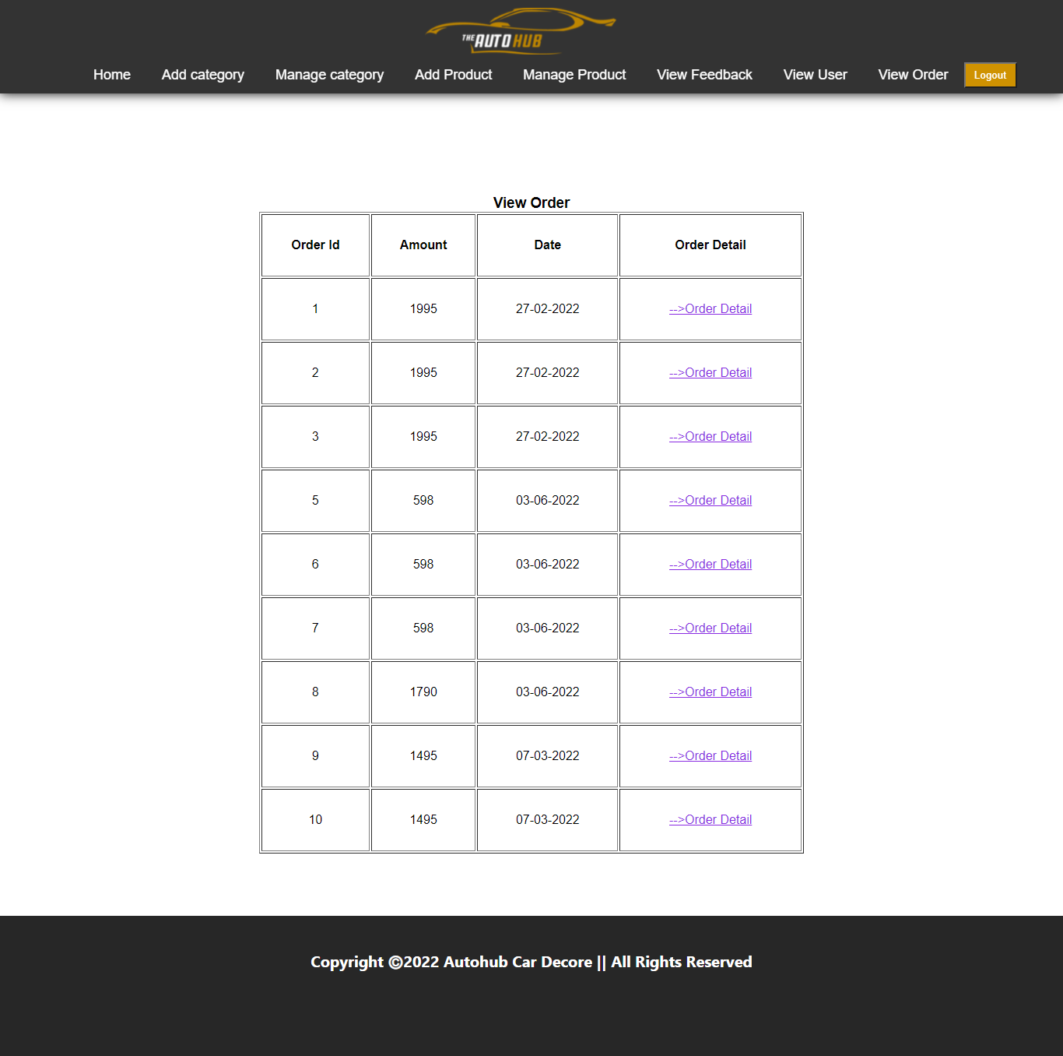

**Order_details.aspx**

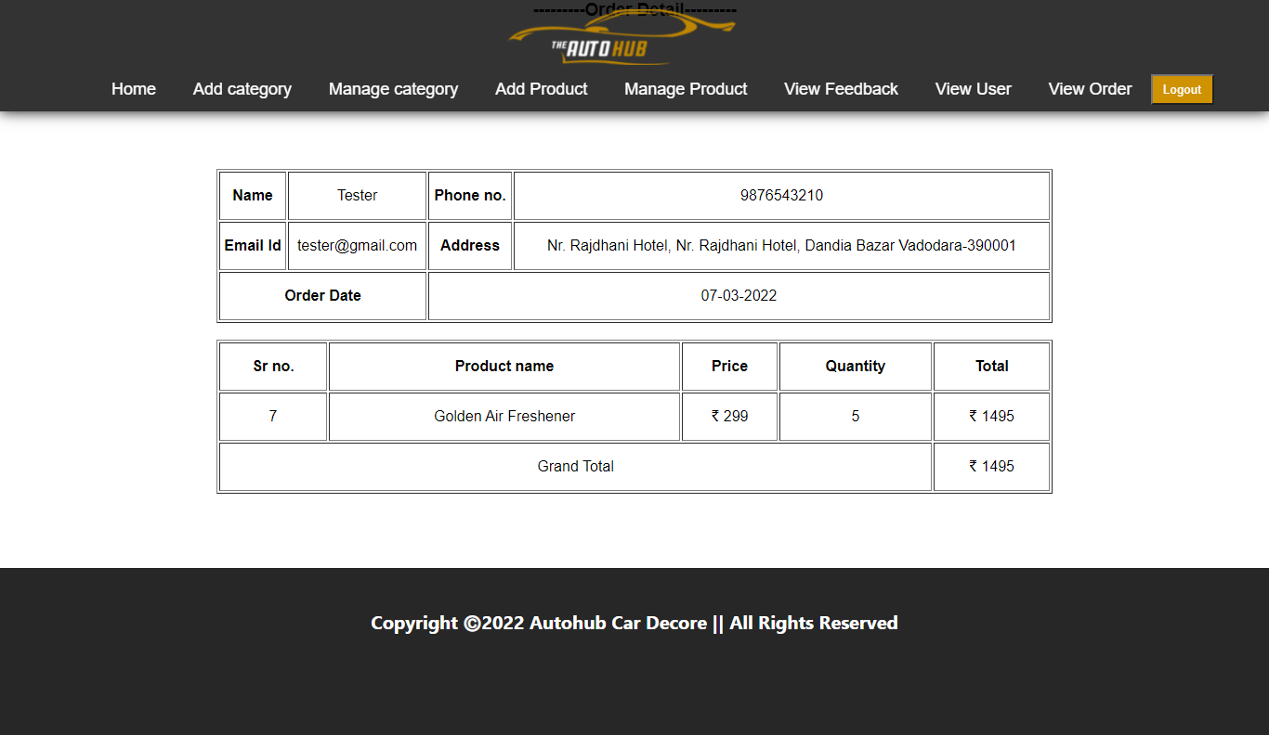

**Coding**

User Site

Masterpage.master

<%@Master Language="C#"AutoEventWireup="true" CodeFile="masterpage.master.cs"Inherits="masterpage"%>

<!DOCTYPE html<html xmlns="http://www.w3.org/1999/xhtml">

<head runat="server">

<link rel="stylesheet" type="text/css" href="style.css">

<title>Master Page Autohub</title>

</head>

<body>

<form id="form1" runat="server">

<header class="header">

<ul class="navigation">

<li><a href="home.aspx">Home</a></li>

<li><a href="about.aspx">About</a></li>

<li><a href="product.aspx">Shop</a></li>

<li><a href="contact.aspx">Contact</a></li>

<li><a href="feedback.aspx">Feedback</a></li>

</ul>

<div class="logo"><img src="img/logo.png" height="60px"/></div>

<div class="user">

<div class="login" id="login1" runat="server">

<%if(Session["userdata"]==null) { %>

<a class="lbtn" href="signin.aspx">SignIN</a> <%} %>

<%else {%>

<a href="cart.aspx">My Cart</a>

<a href="order.aspx">My Order</a>

<a class="lbtn" href="logout.aspx">Log Out</a><%} %>

</div>

</div>

</div>

</header>

<div id="body">

<section class="content-wrapper main-content clear-fix">

<asp:ContentPlaceHolder runat="server" ID="MainContent" />

</section>

</div>

<footer class="footer" id="footer">

<div class="f_content">

<h1>Copyright Ⓒ2022 Autohub Car Decor || All Rights Reserved</h1>

</div>

</footer>

</form>

</body>

</html>

Home.aspx

<%@ Page Title="Home Page" Language="C#" MasterPageFile="~/masterpage.Master" AutoEventWireup="true" CodeFile="home.aspx.cs" Inherits="_Default" %>

<asp:Content runat="server" ID="BodyContent" ContentPlaceHolderID="MainContent">

<section class="banner" id="home">

<div class="heading">

<p>The Auto Hub Gj-10 car decor</p>

<h1>Best Automotive Parts <br />Available</h1>

<a href="about.aspx"><h3>more detail...</h3></a>

</div>

<ul class="sci">

<li><a href="#"><img src="img/facebook2.png"></a></li>

<li><a href="#"><img src="img/instagram2.png"></a></li>

<li><a href="#"><img src="img/twitter2.png"></a></li>

</ul>

</section>

<section class="sec1" id="about">

<div class="detail">

<div class="content">

<h1>Car Service</h1>

<p>The design team(s) responsible for the exterior of the vehicle develops the proportions, shape,

and surface details of the vehicle. Exterior design is first done by a series of manual sketches

and digital drawings. Progressively, drawings that are more detailed are executed and approved by

appropriate layers of management, followed by digital rendering to images. Consumer feedback is

generally sought at this point to help iteratively refine vehicle concepts according to the targeted

market and will continue throughout the rest of the design refinement process. After more progressive

refinement, industrial plasticine and or digital models are developed from and along with the

drawings and images.<br /><br />

The data from these models are then used to create quarter- scale and finally full-sized mock-ups of the final design. With three- and five-axis CNC milling machines, the clay

model is first designed in a computer program and then "carved" using the machine and large amounts of clay.</p>

</div>

<div class="card">

<img src="uploadproduct/pro3.jpg">

<p>Steering Wheel</p>

</div>

</div>

</section>

</asp:Content>

About.aspx

<%@ Page Title="About" Language="C#" MasterPageFile="~/masterpage.Master" AutoEventWireup="true" CodeFile="About.aspx.cs" Inherits="About" %>

<asp:Content runat="server" ID="BodyContent" ContentPlaceHolderID="MainContent">

<section class="sec2">

<div class="banner2"></div>

<div class="info">

<h1 align="center">About US</h1>

<div class="split">

<p>The design team(s) responsible for the exterior of the vehicle develops the proportions, shape, and surface details of the vehicle. Exterior design is first done by a series of manual sketches and digital drawings. Progressively, drawings that are more detailed are executed and approved by appropriate layers of management, followed by digital rendering to images. Consumer feedback generally sought at this point to help iteratively refine vehicle concepts according to the targeted

market and will continue throughout the rest of the design refinement process. After more refinement, industrial plasticine and or digital models are developed from and along with the

drawings and images.<br /><br />

The data from these models are then used to create quarter-scale and finally full-sized mock-ups of the final design. With three- and five-axis CNC milling machines, the clay

model is first designed in a computer program and then "carved" using the machine and large of clay. Even in times of photorealistic 3D (three dimensional) software and virtual models on power

walls, the clay model is still the most important tool for a final evaluation of the exterior design

of a vehicle and, therefore, is used throughout the industry.</p>

<p>The design team(s) responsible for the exterior of the vehicle develops the proportions, shape, and surface details of the vehicle. Exterior design is first done by a series of manual sketches

and digital drawings. Progressively, drawings that are more detailed are executed and approved by

appropriate layers of management, followed by digital rendering to images. Consumer feedback is

generally sought at this point to help iteratively refine vehicle concepts according to the targeted

market and will continue throughout the rest of the design refinement process. After more progressive

refinement, industrial plasticine and or digital models are developed from and along with the

drawings and images.<br /><br />

The data from these models are then used to create quarter-scale and finally full-sized mock-ups of the final design. With three- and five-axis CNC milling machines, the clay

model is first designed in a computer program and then "carved" using the machine and large amounts

of clay. Even in times of photorealistic 3D (three dimensional) software and virtual models on power

walls, the clay model is still the most important tool for a final evaluation of the exterior design

of a vehicle and, therefore, is used throughout the industry.</p>

</div>

</div>

</section>

</asp:Content>

Product.aspx

<%@ Page Title="" Language="C#" MasterPageFile="~/masterpage.master" AutoEventWireup="true" CodeFile="product.aspx.cs" Inherits="product" %>

<%@ Import Namespace="System.Data" %>

<%@ Import Namespace="System.Data.SqlClient" %>

<asp:Content runat="server" ID="BodyContent" ContentPlaceHolderID="MainContent">

<link rel="stylesheet" type="text/css" href="style.css">

<section class="shop">

<div class="box">

<div class="box1"><a href="product.aspx">All</a></div>

<%

SqlConnection con = new SqlConnection("Data Source=PRATIK- PC\\SQLEXPRESS; initial catalog=db_autohub;Integrated Security=True");

SqlCommand cmd1 = new SqlCommand("select * from tbl_category", con);

con.Open();

SqlDataReader dr1 = cmd1.ExecuteReader();

while (dr1.Read()){

%>

<tr>

<td><div class="box1"><a href="product.aspx?cat_id=<%Response.Write( dr1["cat_id"]);%>"><%Response.Write(dr1["cat_name"]); %></a><hr /></div>

</td>

</tr>

<% } dr1.Close();%>

</div>

<%

if (Request.QueryString["cat_id"] != null)

{

SqlCommand cmd = new SqlCommand("select * from tbl_product where pro_cat_id='" + Request.QueryString["cat_id"] + "'", con);

SqlDataReader dr = cmd.ExecuteReader();

%>

<table align="center" style="width:90%; margin-left: 75px;margin-top: 80px; padding-top: 40px">

<%int i = 0; %>

<%while (dr.Read()){

if(i%3==0){

%>

<tr>

<% } %>

<td align="center" style="width: 150px; height: 200px;">

<div class="col-3">

<a href="gallery.aspx?id=<%Response.Write(dr["pro_id"].ToString()); %>">

<img src="uploadproduct/<%Response.Write(dr["pro_image"].ToString()); %>" style="height:250px; width:350px;"/></a>

<div class="content_text">

<h2>

RS: <%Response.Write(dr["pro_price"].ToString()); %>

</h2>

<p>

<%Response.Write(dr["pro_description"].ToString()); %>

</p>

</div>

</div>

<br />

<center><%Response.Write(dr["pro_name"].ToString()); %></center>

<br />

<center><div class="links"><a href="product_detail.aspx?id=<%Response.Write(dr["pro_id"].ToString()); %>&stock=<%Response.Write(dr["pro_stock"].ToString()); %>">View Detail</a></div></center>

</td>

<%i++;

if(i%3==0){ %>

</tr> <%}

} dr.Close();

con.Close();%>

</table><%} else{

SqlCommand cmd = new SqlCommand("select * from tbl_product", con);

SqlDataReader dr = cmd.ExecuteReader();

%>

<table align="center" style="width:90%; margin-left: 75px;margin-top: 80px;padding-top: 40px">

<%int i = 0; %>

<%while (dr.Read()){

if(i%3==0){

%>

<tr>

<% } %>

<td align="center" style="width: 150px; height: 200px;">

<div class="col-3">

<a href="gallery.aspx?id=<%Response.Write(dr["pro_id"].ToString()); %>"><img src="uploadproduct/<%Response.Write(dr["pro_image"].ToString()); %>" style="height:250px; width:350px;"/></a>

<div class="content_text">

<h2>

RS: <%Response.Write(dr["pro_price"].ToString()); %>

</h2>

<p>

<%Response.Write(dr["pro_description"].ToString()); %>

</p>

</div>

</div>

<br />

<center><%Response.Write(dr["pro_name"].ToString()); %></center>

<br />

<center><div class="links"><a href="product_detail.aspx?id=<%Response.Write(dr["pro_id"].ToString()); %>&stock=<%Response.Write(dr["pro_stock"].ToString()); %>">View Detail</a></div></center>

</td>

<%i++;

if(i%3==0){ %>

</tr> <%}

} dr.Close();

con.Close();%>

</table>

<% } %>

</section>

</asp:Content>

Product-details.aspx

<%@ Page Title="" Language="C#" MasterPageFile="~/masterpage.master" AutoEventWireup="true" CodeFile="product_detail.aspx.cs" Inherits="product_detail" %>

<%@ Import Namespace="System.IO" %>

<%@ Import Namespace="System.Data" %>

<%@ Import Namespace="System.Data.SqlClient" %>

<asp:Content runat="server" ID="BodyContent" ContentPlaceHolderID="MainContent">

<section class="pro_det">

<%

SqlConnection con = new SqlConnection("Data Source=PRATIK- PC\\SQLEXPRESS;Initial Catalog=db_autohub;Integrated Security=True");

SqlCommand cmd = new SqlCommand("select * from tbl_product left join tbl_category on tbl_product.pro_cat_id=tbl_category.cat_id where pro_id='"+Request.QueryString["id"].ToString()+"'", con);

con.Open();

SqlDataReader dr = cmd.ExecuteReader();

dr.Read();

%>

<div class="pic">

<img src="uploadproduct/<%Response.Write(dr["pro_image"].ToString()); %>"/>

<div class="content">

<h1><%Response.Write(dr["pro_name"].ToString()); %></h1>

<table>

<tr>

<td><h3>Price:</h3></td>

<td class="input">

<%Response.Write(dr["pro_price"].ToString()); %></td>

</tr>

<tr>

<td><h3>Category:</h3></td>

<td class="input"><%Response.Write(dr["cat_name"].ToString()); %></td>

</tr>

<tr>

<td><h3>Product Description:</h3></td>

<td class="input"><%Response.Write(dr["pro_description"].ToString()); %></td>

</tr>

<tr>

<td><h3>Available Quantity:</h3></td>

<td class="input"><%Response.Write(dr["pro_stock"].ToString()); %></td>

</tr>

<tr>

<td><h3>Select Quantity:</h3></td>

<td class="input"><asp:TextBox ID="TextBox1" runat="server" TextMode="Number"></asp:TextBox></td>

</tr>

</table>

<div class="btn">

<a href="product.aspx">Go Back</a>

<%if(Session["userdata"]==null) { %>

<a href="signin.aspx">Add To Cart</a>

<% }

else

{

%>

<asp:Button ID="btnaddtocart" runat="server" Text="Add To Cart" OnClick="btnaddtocart_Click" />

<% } %>

</div>

</section>

</asp:Content>

Product-details.aspx.cs

using System;

using System.Collections.Generic;

using System.Linq;

using System.Web;

using System.Web.UI;

using System.Web.UI.WebControls;

using System.Data;

using System.Data.SqlClient;

public partial class product_detail : System.Web.UI.Page

{

SqlConnection con;

SqlConnection con1;

SqlCommand cmd;

protected void Page_Load(object sender, EventArgs e)

{

con = new SqlConnection("Data Source=PRATIK-PC\\SQLEXPRESS; initial catalog=db_autohub;Integrated Security=True");

con1 = new SqlConnection("Data Source=PRATIK-PC\\SQLEXPRESS; initial catalog=db_autohub;Integrated Security=True");

}

protected void btnaddtocart_Click(object sender, EventArgs e)

{

SqlCommand cmd1 = new SqlCommand("select * from tbl_cart where c_user_id="+Session["userdata"]+"and c_pro_id="+Request.QueryString["id"],con);

con.Open();

SqlDataReader dr = cmd1.ExecuteReader();

if (dr.Read())

{

string sqty = dr["c_qty"].ToString();

int qty = int.Parse(sqty);

string tqty = TextBox1.Text;

int iqty = int.Parse(tqty);

int fqty = qty + iqty;

cmd = new SqlCommand();

cmd.CommandText = "update tbl_cart set c_qty=" + fqty + "where c_id=" + dr["c_id"];

con1.Open();

cmd.Connection = con1;

cmd.ExecuteNonQuery();

Response.Redirect("cart.aspx");

Response.Write("<script>alert('Update Cart Successful')</script>");

}

else

{

string s = Request.QueryString["stock"];

int istock = int.Parse(s);

string qty = TextBox1.Text;

int iqty = int.Parse(qty);

if (istock > iqty)

{

cmd = new SqlCommand();

cmd.CommandText = "insert into tbl_cart values (" + Session["userdata"] + "," + Request.QueryString["id"] + "," + TextBox1.Text + ")";

con1.Open();

cmd.Connection = con1;

cmd.ExecuteNonQuery();

Response.Write("<script>alert('Added to Cart Successful');window.location.href='product.aspx'</script>");

}

else

{

Response.Write("<script>alert('Enter Valid Qty')</script>");

}

}

dr.Close();

con.Close();

}

Contact.aspx

<%@ Page Title="" Language="C#" MasterPageFile="~/masterpage.master" AutoEventWireup="true" CodeFile="contact.aspx.cs" Inherits="contact" %>

<asp:Content ID="Content1" ContentPlaceHolderID="MainContent" Runat="Server">

<section class="contact">

<center>

<div class="detail">

<h1><u>Contact US</u></h1><br />

<p>Shop no 9, shree namo commercial complex opp,<br />

maru kansara hall,<br />

ranjit sagar road, jamnagar - 361005.

</p><br /><br /><br /><br /><br />

<p>

Phone Number:- 98256 56596<br /><br />

Contact Person:- Nikhil Kothiya<br /><br />

E-mail Address:- nikhilkothiya55@outlook.com

</p>

</div>

</center>

</section>

</asp:Content>

Feedback.aspx

<%@ Page Title="" Language="C#" MasterPageFile="~/masterpage.master" AutoEventWireup="true" CodeFile="feedback.aspx.cs" Inherits="feedback" %>

<asp:Content ID="Content1" ContentPlaceHolderID="MainContent" Runat="Server">

<!DOCTYPE html>

<html>

<head>

<style type="text/css">

body{

background: url(img/sample15.jpg);

background-size: 100% 100%;

}

.container{

padding-top: 120px;

padding-bottom: 50px;

}

.card{

padding: 40px;

height: inherit;

width: 400px;

background: rgba(50, 50, 50, 0.2);

box-shadow: 0 8px 32px 0 rgba(31, 38, 135, 0.37);

backdrop-filter: blur(20.5px);

border-radius: 10px;

border: 1px solid rgba(255, 255, 255, 0.8);

}

h1{

color: black;

font-size: 25px;

}

.card .txt

{

position: relative;

border-bottom: 2px solid #adadad;

margin: 30px 0;

}

.txt input

{

width: 100%;

padding: 0 5px;

height: 40px;

font-size: 16px;

color: #000;

border: none;

background: none;

outline: none;

}

.txt input::placeholder{

color: black;

}

.txt textarea{

width: 100%;

padding: 0 5px;

height: 50px;

letter-spacing: 0px;

font-size: 16px;

color: #000;

border: none;

background: none;

outline: none;

}

.txt textarea::placeholder{

color: black;

}

.btn

{

display: flex;

justify-content: space-around;

}

.btn input

{

width: 150px;

height: 40px;

border: 0.5px solid #fff;

background: #222;

border-radius: 25px;

font-size: 15px;

font-weight: 700;

color: #fff;

cursor: pointer;

transition: .5s ease;

}

.btn input:hover

{

background: white;

color: #222;

}

</style>

</head>

<body>

<section class="feedback">

<div class="container">

<center>

<div class="card">

<h1>Feedback Form</h1>

<div class="txt">

<asp:TextBox ID="TextBox1" runat="server" placeholder="Enter Your Name" height="30px" AutoCompleteType="Disabled"></asp:TextBox>

</div>

<div class="txt">

<asp:TextBox ID="TextBox2" runat="server" placeholder="Enter Your Email" height="30px" AutoCompleteType="Disabled"></asp:TextBox>

</div>

<div class="txt">

<asp:TextBox ID="TextBox3" runat="server" placeholder="Enter Your Subject" height="30px" AutoCompleteType="Disabled"></asp:TextBox>

</div>

<div class="txt">

<asp:TextBox ID="TextBox4" runat="server" placeholder="Enter Your Comment" TextMode="MultiLine" height="50px" AutoCompleteType="Disabled"></asp:TextBox>

</div>

<div class="btn">

<asp:Button ID="Button1" runat="server" Text="Feedback" OnClick="btnfeedback_Click"/>

<asp:Button ID="Button2" runat="server" Text="Clear" OnClick="btnclear_Click"/>

</div>

</div>

</center>

</div>

</section>

</body>

</html>

</asp:Content>

Feedback.aspx.cs

using System;

using System.Collections.Generic;

using System.Linq;

using System.Web;

using System.Web.UI;

using System.Web.UI.WebControls;

using System.Data;

using System.Data.SqlClient;

public partial class feedback : System.Web.UI.Page

{

SqlConnection con;

protected void Page_Load(object sender, EventArgs e)

{

con = new SqlConnection("Data Source=PRATIK-PC\\SQLEXPRESS; initial catalog=db_autohub;Integrated Security=True");

}

protected void btnfeedback_Click(object sender, EventArgs e)

{

SqlCommand cmd = new SqlCommand();

cmd.CommandText = "insert into tbl_feedback values (" + "'" + TextBox1.Text + "'" + "," + "'" + TextBox2.Text + "'" + "," + "'" + TextBox3.Text + "'" + "," + "'" + TextBox4.Text + "')";

cmd.Connection = con;

con.Open();

cmd.ExecuteNonQuery();

Response.Write("<script>alert('Feedback send Successful');window.location.href='home.aspx'</script>");

}

protected void btnclear_Click(object sender, EventArgs e)

{

TextBox1.Text = "";

TextBox2.Text = "";

TextBox3.Text = "";

TextBox4.Text = "";

}

}

Gallary.aspx

<%@ Page Language="C#" AutoEventWireup="true" CodeFile="gallery.aspx.cs" Inherits="gallery" %>

<%@ Import Namespace="System.IO" %>

<%@ Import Namespace="System.Data" %>

<%@ Import Namespace="System.Data.SqlClient" %>

<!DOCTYPE html>

<html xmlns="http://www.w3.org/1999/xhtml">

<head runat="server">

<title>Gallary</title>

<link rel="stylesheet" type="text/css" href="style.css">

</head>

<body class="gallery">

<%

SqlConnection con = new SqlConnection("Data Source=PRATIK- PC\\SQLEXPRESS; initial catalog=db_autohub;Integrated Security=True");

SqlCommand cmd = new SqlCommand("select * from tbl_product where pro_id='"+Request.QueryString["id"].ToString()+"'", con);

con.Open();

SqlDataReader dr = cmd.ExecuteReader();

dr.Read();

%>

<div class="image">

<img src="uploadproduct/<%Response.Write(dr["pro_image"].ToString()); %>”/>

</div>

<div class=”close”>

<a href=”product.aspx”><img src=”img/close.png”/></a>

</div>

</body>

</html>

Cart.aspx

<%@ Page Title="" Language="C#" MasterPageFile="~/masterpage.master" AutoEventWireup="true" CodeFile="cart.aspx.cs" Inherits="cart" %>

<%@ Import Namespace="System.Data" %>

<%@ Import Namespace="System.Data.SqlClient" %>

<asp:Content runat="server" ID="BodyContent" ContentPlaceHolderID="MainContent">

<style>

.cart1 {

padding-top: 150px;

padding-bottom: 100px;

}

.cart1 table tr th{

font-size: 25px;

}

th,td,tr {

height:80px;

}

</style>

<%

SqlConnection con = new SqlConnection("Data Source=PRATIK-PC\\SQLEXPRESS; initial catalog=db_autohub;Integrated Security=True");

SqlCommand cmd= new SqlCommand("select * from tbl_cart join tbl_product on tbl_cart.c_pro_id=tbl_product.pro_id where c_user_id='"+Session["userdata"]+"'", con);

con.Open();

SqlDataReader dr = cmd.ExecuteReader();

%>

<section class="cart1">

<center>

<table style="height:auto; width:600px; text-align:center; border-color:black;" border="1">

<tr>

<th>Product name</th>

<th>price</th>

<th>quantity</th>

<th>total</th>

<th>Remove</th>

</tr>

<% int total = 0;

while (dr.Read())

{

string price = dr["pro_price"].ToString();

int prc = int.Parse(price);

string cqty = dr["c_qty"].ToString();

int qty = int.Parse(cqty);

int sub = prc * qty;

total = total + sub;

%>

<tr>

<td ><%Response.Write(dr["pro_name"]); %></td>

<td>&#8377; <%Response.Write(dr["pro_price"]); %></td>

<td><%Response.Write(dr["c_qty"]); %></td>

<td> &#8377; <%Response.Write(sub); %></td>

<td><a href="cart_remove.aspx?cartid=<%Response.Write(dr["c_id"]); %>" style="text-decoration: none; color: blue;">Remove</a></td>

</tr> <%} %>

<tr>

<td colspan="4">Total</td>

<td>&#8377; <%Response.Write(total); %></td>

</tr>

<tr>

<td colspan="2"><a href="product.aspx" style="text-decoration: none;color: black ">Continue Shoping</a></td>

<td colspan="3"><a href="proceed_to_checkout.aspx" style="text- decoration: none; color: white; padding: 20px 10px; background: #cf9201; border-radius: 25px">Proceed To Checkout</a></td>

</tr>

</table></center>

</section>

</asp:Content>

Cart-remove.aspx

<%@ Page Title="" Language="C#" MasterPageFile="~/masterpage.master" AutoEventWireup="true" CodeFile="cart_remove.aspx.cs" Inherits="cart_remove" %>

<%@ Import Namespace="System.Data" %>

<%@ Import Namespace="System.Data.SqlClient" %>

<asp:Content runat="server" ID="BodyContent" ContentPlaceHolderID="MainContent">

<%

SqlConnection con = new SqlConnection("Data Source=PRATIK- PC\\SQLEXPRESS; initial catalog=db_autohub;Integrated Security=True");

SqlCommand cmd= new SqlCommand("delete from tbl_cart where c_id='"+Request.QueryString["cartid"]+"'", con);

con.Open();

SqlDataReader dr = cmd.ExecuteReader();

dr.Read();

Response.Redirect("cart.aspx");

%>

</asp:Content>

Proceed-to-checkout.aspx

<%@ Page Title="" Language="C#" MasterPageFile="~/masterpage.master" AutoEventWireup="true" CodeFile="proceed_to_checkout.aspx.cs" Inherits="proceed_to_checkout" %>

<%@ Import Namespace="System.Data" %>

<%@ Import Namespace="System.Data.SqlClient" %>

<asp:Content runat="server" ID="BodyContent" ContentPlaceHolderID="MainContent">

<style>

.checkout {

padding-top: 150px;

padding-bottom: 100px;

padding-left: 100px;

}

.checkout .cktbl{

padding: 20px;

background: #d9d9d9;

}

.cktbl .innertbl1 {

margin: 50px;

}

.cktbl .innertbl1 tr th{

font-size: 20px;

height: 30px;

padding: 10px;

background: none;

color: black;

}

.cktbl .innertbl1 tr .btn input{

padding: 5px;

background: #cf9201;

color: white;

border: none;

font-size: 15px;

margin: 10px;

}

.cktbl .innertbl1 tr td {

padding: 10px;

}

.cktbl .innertbl1 tr td input{

padding: 10px;

width:88%;

}

.cktbl .innertbl1 tr td textarea{

padding: 10px;

}

.cktbl .innertbl2 {

margin-left: 230px;

margin-right: 50px;

}

.cktbl .innertbl2 tr th{

font-size: 20px;

height: 30px;

padding: 10px;

background : #cf9201;

color:white;

}

.cktbl .innertbl2 .total td {

padding: 10px;

}

.cktbl .innertbl2 tr td{

padding: 50px 10px;

}

</style>

<section class="checkout">

<table class="cktbl">

<tr>

<td>

<h3 align="center">Billing & Shipping Address</h3>

<table border="1" class="innertbl1">

<tr>

<th>Name</th>

<td><asp:TextBox ID="txtname" runat="server"></asp:TextBox></td>

</tr>

<tr>

<th>Email</th>

<td><asp:TextBox ID="txtemail" runat="server"></asp:TextBox></td>

</tr>

<tr>

<th>Phone</th>

<td><asp:TextBox ID="txtphone" runat="server"></asp:TextBox></td>

</tr>

<tr>

<th>Address</th>

<td><asp:TextBox ID="txtaddress" runat="server" TextMode="MultiLine">

</asp:TextBox></td>

</tr>

<tr>

<td colspan=2 class="btn"><p align="center">

<asp:Button ID="btnorder" runat="server" Text="Place Order" OnClick="btnorder_Click" /></p></td>

</tr>

</table>

</td>

<td>

<%

SqlConnection con = new SqlConnection("Data Source=PRATIK- PC\\SQLEXPRESS; initial catalog=db_autohub;Integrated Security=True");

SqlCommand cmd= new SqlCommand("select * from tbl_cart join tbl_product on tbl_cart.c_pro_id=tbl_product.pro_id where c_user_id='"+Session["userdata"]+"'", con);

con.Open();

SqlDataReader dr = cmd.ExecuteReader();

%>

<center><table border="1" class="innertbl2">

<tr>

<th>Product name</th>

<th>price</th>

<th>quantity</th>

<th>total</th>

</tr>

<% int total = 0;

while (dr.Read())

{

string price = dr["pro_price"].ToString();

int prc = int.Parse(price);

string cqty = dr["c_qty"].ToString();

int qty = int.Parse(cqty);

int sub = prc * qty;

total = total + sub;

%>

<tr>

<td ><%Response.Write(dr["pro_name"]); %></td>

<td>&#8377; <%Response.Write(dr["pro_price"]); %></td>

<td><%Response.Write(dr["c_qty"]); %></td>

<td> &#8377; <%Response.Write(sub); %></td>

</tr> <%} %>

<tr class="total">

<td colspan="3">Total</td>

<td>&#8377; <%Response.Write(total); %></td>

</tr>

<%dr.Close(); %>

</table></center>

</td>

</tr>

</table>

</section>

</asp:Content>

Proceed-to-checkout.aspx.cs

using System;

using System.Collections.Generic;

using System.Linq;

using System.Web;

using System.Web.UI;

using System.Web.UI.WebControls;

using System.Data;

using System.Data.SqlClient;

public partial class proceed_to_checkout : System.Web.UI.Page

{

SqlConnection con1 = new SqlConnection("Data Source=PRATIK- PC\\SQLEXPRESS; initial catalog=db_autohub;Integrated Security=True");

SqlConnection con = new SqlConnection("Data Source=PRATIK- PC\\SQLEXPRESS; initial catalog=db_autohub;Integrated Security=True");

protected void Page_Load(object sender, EventArgs e)

{

SqlCommand cmd = new SqlCommand("select * from tbl_user where user_id='" + Session["userdata"] + "'", con);

con.Open();

SqlDataReader dr = cmd.ExecuteReader();

dr.Read();

txtname.Text=dr["user_name"].ToString();

txtemail.Text = dr["user_email"].ToString();

txtphone.Text = dr["user_phone"].ToString();

txtaddress.Text = dr["user_address"].ToString();

dr.Close();

con.Close();

}

protected void btnorder_Click(object sender, EventArgs e)

{

SqlCommand cmd1 = new SqlCommand("select sum(pro_price*c_qty) as amount, count(c_id) as ttl from tbl_cart join tbl_product on tbl_cart.c_pro_id=tbl_product.pro_id where c_user_id='" + Session["userdata"] + "'", con);

con.Open();

SqlDataReader dr1 = cmd1.ExecuteReader();

dr1.Read();

SqlCommand cmd3 = new SqlCommand();

cmd3.CommandText = "insert into tbl_order values(" + "'" + Session["userdata"] + "'" + "," + "'" + txtname.Text + "'" + "," + "'" + txtemail.Text + "'" + "," + "'" + txtphone.Text + "'" + "," + "'" + txtaddress.Text + "'" + "," + "'" + dr1["amount"].ToString() + "'" + "," + "'" + DateTime.Today + "'" + ")";

string r = dr1["ttl"].ToString();

int count = int.Parse(r);

dr1.Close();

cmd3.Connection = con;

cmd3.ExecuteNonQuery();

SqlCommand cmd2 = new SqlCommand("select MAX(o_id) as order_id from tbl_order", con);

SqlDataReader dr2 = cmd2.ExecuteReader();

dr2.Read();

string s = dr2["order_id"].ToString();

dr2.Close();

SqlCommand cmd4 = new SqlCommand("select * from tbl_cart join tbl_product on tbl_cart.c_pro_id=tbl_product.pro_id where c_user_id='" + Session["userdata"] + "'", con);

SqlDataReader dr4 = cmd4.ExecuteReader();

while (dr4.Read())

{

string pid = dr4["pro_id"].ToString();

string name = dr4["pro_name"].ToString();

string price = dr4["pro_price"].ToString();

int prc = int.Parse(price);

string cqty = dr4["c_qty"].ToString();

int qty = int.Parse(cqty);

int sub = prc * qty;

SqlCommand cmd5 = new SqlCommand();

cmd5.CommandText = "insert into tbl_order_item values(" + "'" + s + "'" + "," + "'" + pid + "'" + "," + "'" + name + "'" + "," + "'" + price + "'" + "," + "'" + cqty + "'" + "," + "'" + sub + "'" + ")";

con1.Open();

cmd5.Connection = con1;

cmd5.ExecuteNonQuery();

con1.Close();

}

dr4.Close();

SqlCommand cmd6 = new SqlCommand("delete from tbl_cart where c_user_id='" + Session["userdata"] + "'", con);

SqlDataReader dr5 = cmd6.ExecuteReader();

dr5.Read();

dr5.Close();

con.Close();

Response.Write("<script>alert('Place Order successful')</script>");

Response.Redirect("home.aspx");

}

Order.aspx

<%@ Page Title="" Language="C#" MasterPageFile="~/masterpage.master" AutoEventWireup="true" CodeFile="order.aspx.cs" Inherits="order" %>

<%@ Import Namespace="System.Data" %>

<%@ Import Namespace="System.Data.SqlClient" %>

<asp:Content runat="server" ID="BodyContent" ContentPlaceHolderID="MainContent">

<style>

.order {

padding-top: 150px;

padding-bottom: 100px;

}

td, th {

height: 80px;

text-align: center;

}

td a {

text-decoration: none;

color: blue;

}

</style>

<%

SqlConnection con = new SqlConnection("Data Source=PRATIK- PC\\SQLEXPRESS; initial catalog=db_autohub;Integrated Security=True");

SqlCommand cmd = new SqlCommand("select * from tbl_order where o_user_id='" + Session["userdata"] + "'", con);

con.Open();

SqlDataReader dr = cmd.ExecuteReader();

%>

<section class="order">

<center>

<h3 align="center">--------Order Detail--------</h3>

<table style="color:black; width:700px; height:auto; margin-top: 50px;" border="1">

<tr>

<th>Order Id</th>

<th>Amount</th>

<th>Date</th>

<th>Order Detail</th>

</tr>

<%while (dr.Read())

{ %>

<tr>

<td><%Response.Write(dr["o_id"]); %></td>

<td>&#8377;<%Response.Write(dr["o_amount"]); %></td>

<td><%Response.Write(((DateTime)dr["o_date"]).ToString("dd- MM-yyyy")); %></td>

<td>

<a href="order_detail.aspx?order_id=

<%Response.Write(dr["o_id"].ToString()); %>">-->Order Detail</a>

</td>

</tr>

<%} %>

</table>

</center>

</section>

</asp:Content>

Order-details.aspx

<%@ Page Title="" Language="C#" MasterPageFile="~/masterpage.master" AutoEventWireup="true" CodeFile="order_detail.aspx.cs" Inherits="order_detail" %>

<%@ Import Namespace="System.Data" %>

<%@ Import Namespace="System.Data.SqlClient" %>

<asp:Content runat="server" ID="BodyContent" ContentPlaceHolderID="MainContent">

<style>

.invoice {

padding-top: 120px;

padding-bottom: 100px;

}

.invoice center {

display: flex;

}

.invoice .tbl1 {

margin: 50px;

width: 570px;

}

.invoice .tbl1 th {

font-size: 20px;

height: 50px;

}

.invoice .tbl1 td {

padding: 20px;

}

.invoice .tbl2 {

margin: 50px;

width: 570px;

}

.invoice .tbl2 th {

font-size: 20px;

height: 40px;

}

.invoice .tbl2 td {

padding: 20px;

}

</style>

<%

SqlConnection con = new SqlConnection("Data Source=PRATIK- PC\\SQLEXPRESS; initial catalog=db_autohub;Integrated Security=True");

SqlCommand cmd = new SqlCommand("select * from tbl_order_item where oi_order_id='" + Request.QueryString["order_id"] + "'", con);

con.Open();

SqlDataReader dr = cmd.ExecuteReader();

SqlConnection con1 = new SqlConnection("Data Source=PRATIK- PC\\SQLEXPRESS; initial catalog=db_autohub;Integrated Security=True");

SqlCommand cmd1 = new SqlCommand("select * from tbl_order where o_id='" + Request.QueryString["order_id"] + "'", con1);

con1.Open();

SqlDataReader dr1 = cmd1.ExecuteReader();

dr1.Read();

%>

<section class="invoice">

<h3 align="center">---------INVOICE---------</h3>

<center>

<table class="tbl1" border="1">

<tr>

<th>Name</th>

<td><%Response.Write(dr1["o_name"]); %></td>

</tr>

<tr>

<th>Phone no.</th>

<td><%Response.Write(dr1["o_phone"]); %></td>

</tr>

<tr>

<th>Email Id</th>

<td><%Response.Write(dr1["o_email"]); %></td>

</tr>

<tr>

<th>Address</th>

<td><%Response.Write(dr1["o_address"]); %></td>

</tr>

<tr>

<th>Order Date</th>

<td><%Response.Write(((DateTime)dr1["o_date"]).ToString("dd-MM-yyyy")); %></td>

</tr>

</table>

<%dr1.Close();

con1.Close(); %>

<table class="tbl2" style="color:black; width:900px;" border="1">

<tr>

<th>Sr no.</th>

<th>Product name</th>

<th>Price</th>

<th>Quantity</th>

<th>Total</th>

</tr>

<%int total = 0; while (dr.Read())

{ %>

<tr>

<td><%Response.Write(dr["oi_id"]); %></td>

<td><%Response.Write(dr["oi_pname"]); %></td>

<td>&#8377; <%Response.Write(dr["oi_price"]); %></td>

<td><%Response.Write(dr["oi_qty"]); %></td>

<td>&#8377; <%Response.Write(dr["oi_amount"]); %></td>

</tr>

<% string price = dr["oi_price"].ToString();

int prc = int.Parse(price);

string oqty = dr["oi_qty"].ToString();

int qty = int.Parse(oqty);

int sub = prc * qty;

total = total + sub;

}%>

<tr>

<td colspan="4">Grand Total</td>

<td>&#8377; <%Response.Write(total); dr.Close(); con.Close();%>

</td>

</tr>

</table>

</center>

</section>

</asp:Content>

Sign-in.aspx

<%@ Page Title="" Language="C#" MasterPageFile="~/masterpage.master" AutoEventWireup="true" CodeFile="signin.aspx.cs" Inherits="signin" %>

<asp:Content runat="server" ID="BodyContent" ContentPlaceHolderID="MainContent">

<head>

<style type="text/css">

body {

background: url(img/sample5.jpg);

background-size: 100% 120vh;

}

.signin {

height: 100vh;

}

.container {

padding-top: 170px;

}

.card {

padding: 40px;

height: inherit;

width: 400px;

background: rgba(155, 155, 155, 0.2);

box-shadow: 0 8px 32px 0 rgba(31, 38, 135, 0.37);

backdrop-filter: blur(18.5px);

border-radius: 10px;

border: 1px solid rgba(255, 255, 255, 0.8);

}

h1 {

color: #222;

font-size: 24px;

text-transform: uppercase;

letter-spacing: 2px;

}

.card .txt {

position: relative;

border-bottom: 2px solid rgba(255, 255, 255, 0.8);

margin: 30px 0;

}

.txt input {

width: 100%;

padding: 0 5px;

height: 40px;

font-size: 16px;

color: #000;

border: none;

background: none;

outline: none;

}

.txt input::placeholder {

color: black;

}

.btn {

display: flex;

justify-content: space-around;

}

.btn input {

width: 150px;

height: 40px;

border: 0.5px solid #fff;

background: #222;

border-radius: 25px;

font-size: 15px;

font-weight: 700;

color: #fff;

cursor: pointer;

transition: .5s ease;

}

.btn input:hover {

background: white;

color: #222;

}

.link {

margin-top: 30px;

}

.link a {

text-decoration: none;

color: black;

font-size: 20px;

}

.link a:hover {

color: blue;

text-decoration: underline;

}

</style>

</head>

<body>

<section class="signin">

<div class="container">

<center>

<div class="card">

<h1>Sign IN</h1>

<div class="txt">

<asp:TextBox ID="txtname" runat="server" placeholder="Enter Your Email" height="30px" AutoCompleteType="Disabled" TextMode="Email"></asp:TextBox>

</div>

<div class="txt">

<asp:TextBox ID="txtpass" runat="server" placeholder="Enter Your Password" height="30px" TextMode="Password"></asp:TextBox>

</div>

<div class="btn">

<asp:Button ID="Button1" runat="server" Text="SignIn" OnClick="btnsignin_Click"/>

<asp:Button ID="Button2" runat="server" Text="Cancel" OnClick="btncancel_Click"/>

</div>

<div class="link">

<a href="signup.aspx">Create new account</a>

</div>

</div>

</center>

</div>

</section>

</body>

</asp:Content>

Sign-in.aspx.cs

using System;

using System.Collections.Generic;

using System.Linq;

using System.Web;

using System.Web.UI;

using System.Web.UI.WebControls;

using System.Data;

using System.Data.SqlClient;

public partial class signin : System.Web.UI.Page

{

SqlConnection con;

SqlCommand cmd;

protected void Page_Load(object sender, EventArgs e)

{

con = new SqlConnection("Data Source=PRATIK-PC\\SQLEXPRESS; initial catalog=db_autohub;Integrated Security=True");

}

protected void btnsignin_Click(object sender, EventArgs e)

{

cmd = new SqlCommand("select * from tbl_user where user_email='" + txtname.Text + "' and user_password='" + txtpass.Text + "'", con);

con.Open();

SqlDataReader dr = cmd.ExecuteReader();

if ((txtpass.Text == "") || (txtname.Text == ""))

{

Response.Write("<script>alert('Password and username should not be blank')</script>");

}

else {

if (dr.Read())

{

Session["userdata"] = dr[0];

Response.Write("<script>alert('Login successfully')</script>");

Response.Redirect("home.aspx");

}

else

{

Response.Write("<script>alert('Invalid Username or password')</script>");

}

}

}

protected void btncancel_Click(object sender, EventArgs e)

{

Response.Redirect("home.aspx");

}

}

Sign-up.aspx

<%@ Page Title="" Language="C#" MasterPageFile="~/masterpage.master" AutoEventWireup="true" CodeFile="signup.aspx.cs" Inherits="signup" %>

<asp:Content runat="server" ID="BodyContent" ContentPlaceHolderID="MainContent">

<head>

<style type="text/css">

body {

background: url(img/sample6.jpg);

background-size: 100% 120vh;

}

.signup {

padding-bottom: 50px;

}

.container {

padding-top: 120px;

}

.card {

padding: 40px;

height: inherit;

width: 400px;

background: rgba(155, 155, 155, 0.2);

box-shadow: 0 8px 32px 0 rgba(31, 38, 135, 0.37);

backdrop-filter: blur(8.5px);

border-radius: 10px;

border: 1px solid rgba(255, 255, 255, 0.8);

}

h1 {

color: #222;

font-size: 24px;

text-transform: uppercase;

letter-spacing: 2px;

}

.card .txt {

position: relative;

border-bottom: 2px solid rgba(255, 255, 255, 0.8);

margin: 30px 0;

}

.txt input {

width: 100%;

padding: 0 5px;

height: 40px;

font-size: 16px;

color: #000;

border: none;

background: none;

outline: none;

}

.txt input::placeholder {

color: black;

}

.txt textarea {

width: 100%;

padding: 0 5px;

height: 40px;

font-size: 16px;

color: #000;

border: none;

background: none;

outline: none;

}

.txt textarea::placeholder {

color: black;

}

.btn {

display: flex;

justify-content: space-around;

}

.btn input {

width: 150px;

height: 40px;

border: 0.5px solid #fff;

background: #222;

border-radius: 25px;

font-size: 15px;

font-weight: 700;

color: #fff;

cursor: pointer;

transition: .5s ease;

}

.btn input:hover {

background: white;

color: #222;

}

.link {

margin-top: 30px;

}

.link a {

text-decoration: none;

color: black;

font-size: 20px;

}

.link a:hover {

color: blue;

text-decoration: underline;

}

</style>

</head>

<body>

<section class="signup">

<div class="container">

<center>

<div class="card">

<h1>Sign UP</h1>

<div class="txt">

<asp:TextBox ID="txtname" runat="server" placeholder="Enter Your Name" height="30px" AutoCompleteType="Disabled"></asp:TextBox>

</div>

<div class="txt">

<asp:TextBox ID="txtemail" runat="server" placeholder="Enter Your Email" height="30px" TextMode="Email"></asp:TextBox>

</div>

<div class="txt">

<asp:TextBox ID="txtpass" runat="server" placeholder="Enter Your Password" height="30px" TextMode="Password"></asp:TextBox>

</div>

<div class="txt">

<asp:TextBox ID="txtmobile" runat="server" placeholder="Enter Your Mobile" height="30px" TextMode="Phone" AutoCompleteType="Disabled"></asp:TextBox>

</div>

<div class="txt">

<asp:TextBox ID="txtaddress" runat="server" placeholder="Enter Your Address" height="30px" TextMode="MultiLine" AutoCompleteType="Disabled"></asp:TextBox>

</div>

<div class="btn">

<asp:Button ID="Button1" runat="server" Text="SignUP" OnClick="btnsignup_Click"/>

<asp:Button ID="Button2" runat="server" Text="Cancel" OnClick="btncancel_Click"/>

</div>

</div>

</center>

</div>

</section>

</body>

</asp:Content>

Sign-up.aspx.cs

using System;

using System.Collections.Generic;

using System.Linq;

using System.Web;

using System.Web.UI;

using System.Web.UI.WebControls;

using System.Data;

using System.Data.SqlClient;

public partial class signup : System.Web.UI.Page

{

SqlConnection con;

SqlCommand cmd;

protected void Page_Load(object sender, EventArgs e)

{

con = new SqlConnection("Data Source=PRATIK-PC\\SQLEXPRESS; initial catalog=db_autohub;Integrated Security=True");

}

protected void btnsignup_Click(object sender, EventArgs e)

{

cmd=new SqlCommand();

cmd.CommandText = "insert into tbl_user values ("+"'"+txtname.Text+"'"+","+"'"+txtemail.Text+"'"+","+"'"+txtmobile.Text+"'"+", "+"'"+txtaddress.Text+"'"+","+"'"+txtpass.Text+"')";

cmd.Connection = con;

con.Open();

cmd.ExecuteNonQuery();

if ((txtname.Text == "") || (txtemail.Text == "") || (txtpass.Text == "") || (txtmobile.Text == "") || (txtaddress.Text == ""))

{

Response.Write("<script>alert('Fields can not be blank')</script>");

}

else if (txtpass.Text.Length < 7)

{

Response.Write("<script>alert('Password must be more than 6 characters')</script>");

}

else if ((txtmobile.Text.Length > 10) || (txtmobile.Text.Length < 10))

{

Response.Write("<script>alert('Mobile number must be 10 digits')</script>");

}

else

{

Response.Write("<script>alert('Signup Successful')</script>");

Response.Redirect("signin.aspx");

}

}

protected void btncancel_Click(object sender, EventArgs e)

{

Response.Redirect("signin.aspx");

}

}

Logout.aspx.cs

using System;

using System.Collections.Generic;

using System.Linq;

using System.Web;

using System.Web.UI;

using System.Web.UI.WebControls;

public partial class logout : System.Web.UI.Page

{

protected void Page_Load(object sender, EventArgs e)

{

Session["userdata"] = null;

Response.Redirect("home.aspx");

}

}

Style.css

* {

margin: 0;

padding: 0;

font-family: helvetica;

scroll-behavior: smooth;

}

body {

overflow-x: hidden;

}

.header {

display: flex;

position: fixed;

padding: 20px;

background: rgba(0,0,0,.8);

z-index: 20;

height: 40px;

width: 100%;

box-shadow: 0 0 15px black;

transition: 0.5s;

}

.navigation {

display: flex;

position: fixed;

justify-content: center;

align-items: center;

padding-top: 10px;

padding-left: 25px;

transition: 0.5s;

}

.navigation li {

list-style: none;

}

.navigation li a {

color: white;

font-size: 18px;

padding: 20px;

font-weight: 500;

text-decoration: none;

transition: .5s ease;

}

.navigation li a.active {

color: #cf9201;

filter: brightness(1.2);

}

.navigation li a:hover {

color: #cf9201;

filter: brightness(1.2);

}

.logo {

display: flex;

justify-content: center;

align-items: center;

padding-left: 750px;

}

.user {

position: fixed;

right: 25px;

display: flex;

align-items: center;

margin-top: 10px;

z-index: 500;

cursor: pointer;

}

.user .login .lbtn {

padding: 10px;

transition: .5s;

}

.user .login .lbtn:hover {

background: #cf9201;

padding: 10px;

border-radius: 15px;

color: black;

}

.user input {

filter: invert(1);

}

.user .login a {

color: white;

text-decoration: none;

margin-right: 10px;

transition: 0.5s;

}

.user .login a:hover {

filter: brightness(1.2);

color: #cf9201;

}

.banner {

background-repeat: none;

background: url(img/1.jpg);

background-size: cover;

height: 100vh;

}

.banner .heading {

position: absolute;

top: 30%;

left: 10%;

}

.banner .heading h1 {

margin-top: 15px;

color: #fff;

font-size: 40px;

font-weight: bolder;

}

.banner .heading h3 {

font-family: sans-serif;

margin-top: 25px;

font-size: 18px;

color: #fff;

letter-spacing: 1px;

}

.banner .heading p {

font-family: sans-serif;

margin-top: 25px;

color: #fff;

letter-spacing: 1px;

}

.sci {

position: fixed;

z-index: 10;

bottom: 20px;

display: flex;

justify-content: center;

align-items: center;

right: 10px;

}

.sci li {

list-style: none;

margin-right: 40px;

height: 35px;

width: 35px;

overflow: hidden;

background: #fff;

border-radius: 25px;

box-shadow: 3px 3px 4px #222;

transition: 0.3s;

}

.sci li:hover {

opacity: 0.6;

}

.sci li a {

display: flex;

height: 35px;

width: 35px;

}

.sec1 {

padding-top: 40px;

}

.sec1 .detail {

display: flex;

justify-content: space-evenly;

margin: 20px;

}

.sec1 .content {

width: 50%;

}

.sec1 .content h1 {

padding-top: 10px;

font-size: 40px;

}

.sec1 .content p {

padding-top: 25px;

font-size: 20px;

}

.card {

height: 400px;

width: 600px;

margin-left: 5px;

overflow: hidden;

}

.card img {

height: inherit;

width: inherit;

}

.card p {

display: flex;

justify-content: center;

align-items: center;

padding: 5px 0px;

background: #000;

color: #fff;

transition: 0.3s;

}

.card:hover p {

transform: translateY(-32px);

}

.sec2 {

padding-top: 80px;

height: inherit;

width: 100%;

}

.sec2 .banner2 {

background: url(img/banner.jpg);

height: 435px;

width: 100%;

background-size: 100% 100%;

}

.sec2 .info {

margin: 60px;

}

.sec2 .info .split {

display: flex;

margin: 5px;

}

.sec2 .info h1 {

margin: 40px;

font-size: 30px;

}

.sec2 .info p {

letter-spacing: 1px;

margin: 20px;

}

span {

margin-left: 50px;

}

.sec2 .content {

display: flex;

justify-content: space-evenly;

margin-top: 50px;

margin-bottom: 50px;

flex-wrap: wrap;

}

.sec2 .content .card3 {

position: relative;

height: inherit;

width: 350px;

margin: 20px;

border-radius: 20px;

background: lightgray;

}

.sec2 .content .card3 .text {

position: relative;

padding: 25px 10px;

top: 10px;

}

.sec2 .content .card3 .text img {

position: relative;

left: 42%;

height: 40px;

width: 40px;

}

.sec2 .content .card3 .text p {

margin: 30px;

}

.gallery {

width: 100%;

background: #555;

}

.gallery .image {

display: flex;

margin-top: 30px;

justify-content: center;

align-items: center;

}

.gallery img {

height: 90vh;

width: 90%;

}

.gallery .close {

position: absolute;

top: 30px;

left: 20px;

}

.gallery .close img {

cursor: pointer;

height: 40px;

width: 40px;

}

.shop {

padding-top: 100px;

height: inherit;

width: 100%;

background: linear- gradient(rgba(255,255,255,.5),rgba(255,255,255,.5)),url(img/sample15.jpg);

background-size: 100% 100vh;

background-attachment: fixed;

}

.shop .box {

position: fixed;

display: flex;

justify-content: space-between;

height: 50px;

width: 80%;

background: rgba(255,255,255,.7);

border-radius: 25px;

top: 90px;

z-index: 40;

left: 11.5%;

box-shadow: 2px 2px 50px #444;

overflow: hidden;

}

.links {

margin-bottom: 10px;

}

.links a {

text-decoration: none;

padding: 5px;

filter: brightness(1.2);

background: #cf9201;

font-size: 18px;

color: black;

transition: .5s;

}

.links a:hover {

background: none;

}

.box .box1 {

height: inherit;

display: flex;

justify-content: center;

align-items: center;

width: inherit;

transition: 0.5s ease;

}

.box .box1:hover {

background: #00a2ff;

transform: scale(1.1);

}

.box .box1 a {

color: black;

padding: 20px 50px;

text-decoration: none;

}

.content_text h2 {

transform: translate(-200px,-200px);

opacity: 0;

color: white;

font-size: 28px;

pointer-events: none;

transition: .5s;

}

.content_text p {

transform: translate(400px,-170px);

opacity: 0;

pointer-events: none;

color: white;

transition: .5s;

font-size: 22px;

}

.shop table .col-3 {

overflow: hidden;

height: 250px;

width: 350px;

}

.shop table img:hover {

filter: brightness(.4);

transition: .5s;

}

.shop table .col-3:hover .content_text h2 {

transform: translate(-5px,-200px);

opacity: 1;

}

.shop table .col-3:hover .content_text p {

transform: translate(-5px,-170px);

opacity: 1;

}

.pro_det {

padding-top: 80px;

}

/*Contact US*/

.detail {

padding-top: 120px;

padding-bottom: 50px;

}

.contact .detail h1 {

font-size: 30px;

text-transform: uppercase;

letter-spacing: 5px;

margin: 20px;

}

.contact .detail p {

font-size: 24px;

word-spacing: 3px;

}

.pic {

display: flex;

}

.pic img {

position: relative;

height: inherit;

width: 50%;

z-index: -1;

}

.pic .content {

margin-left: 2%;

color: #000;

}

.pic .content h1 {

font-size: 40px;

margin: 10px;

}

.pic .content p {

font-size: 20px;

margin-top: 20px;

}

.pic .content table {

margin: 30px;

width: 620px;

}

.pic .content table td {

padding: 20px 35px;

}

.pic .content table h3 {

font-size: 20px;

font-weight: normal;

}

.pic .content table .input {

width: 80%;

}

.pic .content input {

width: 100%;

height: 25px;

font-size: 20px;

padding-left: 5px;

}

.pic .content .btn {

display: flex;

justify-content: center;

align-items: center;

}

.pic .content .btn input {

margin: 10px 25px 40px;

filter: brightness(1.2);

background: #cf9201;

color: white;

padding: 10px;

border-radius: 25px;

width: inherit;

height: inherit;

border: none;

font-size: 21px;

font-weight: bold;

transition: .4s;

}

.pic .content .btn input:hover {

background: none;

color: #000;

}

.pic .content .btn a {

text-decoration: none;

margin: 10px 25px 40px;

filter: brightness(1.2);

background: #cf9201;

color: white;

padding: 10px;

border-radius: 25px;

font-size: 21px;

font-weight: bold;

transition: .4s;

}

.pic .content .btn a:hover {

background: none;

color: #000;

}

.footer {

height: 180px;

background: #272727;

}

footer .f_content {

display: flex;

justify-content: center;

align-items: center;

}

footer .f_content h1 {

font-size: 20px;

font-family: Ebrima;

color: #fff;

margin: 45px;

}

Admin site

Admin-login.aspx

<%@ Page Language="C#" AutoEventWireup="true" CodeFile="admin_login.aspx.cs" Inherits="admin_login" %>

<!DOCTYPE html>

<html xmlns="http://www.w3.org/1999/xhtml">

<head runat="server">

<title>Admin Login</title>

<style type="text/css">

body {

background: url(img/sample15.jpg);

background-size: 100% 120vh;

}

.signin {

height: 100vh;

}

.container {

padding-top: 170px;

}

.card {

padding: 40px;

height: inherit;

width: 400px;

background: rgba(155, 155, 155, 0.2);

box-shadow: 0 8px 32px 0 rgba(31, 38, 135, 0.37);

backdrop-filter: blur(18.5px);

border-radius: 10px;

border: 1px solid rgba(255, 255, 255, 0.8);

}

h1 {

color: #222;

font-size: 24px;

text-transform: uppercase;

letter-spacing: 2px;

}

.card .txt {

position: relative;

border-bottom: 2px solid rgba(255, 255, 255, 0.8);

margin: 30px 0;

}

.txt input {

width: 100%;

padding: 0 5px;

height: 40px;

font-size: 16px;

color: #000;

border: none;

background: none;

outline: none;

}

.txt input::placeholder {

color: black;

}

.btn {

display: flex;

justify-content: space-around;

}

.btn input {

width: 150px;

height: 40px;

border: 0.5px solid #fff;

background: #222;

border-radius: 25px;

font-size: 15px;

font-weight: 700;

color: #fff;

cursor: pointer;

transition: .5s ease;

}

.btn input:hover {

background: white;

color: #222;

}

</style>

</head>

<body>

<section class="signin">

<form runat="server">

<div class="container">

<center>

<div class="card">

<h1>Admin Login</h1>

<div class="txt">

<asp:TextBox ID="txtname" runat="server" placeholder="Enter Your Email" height="30px" AutoCompleteType="Disabled" TextMode="Email"></asp:TextBox>

</div>

<div class="txt">

<asp:TextBox ID="txtpass" runat="server" placeholder="Enter Your Password" height="30px" TextMode="Password"></asp:TextBox>

</div>

<div class="btn">

<asp:Button ID="Button1" runat="server" Text="Login" OnClick="btnsignin_Click"/>

<asp:Button ID="Button2" runat="server" Text="Clear" OnClick="btnclear_Click"/>

</div>

</div>

</center>

</div>

</form>

</section>

</body>

</html>

Admin-login.aspx.cs

using System;

using System.Collections.Generic;

using System.Linq;

using System.Web;

using System.Web.UI;

using System.Web.UI.WebControls;

using System.Data;

using System.Data.SqlClient;

public partial class admin_login : System.Web.UI.Page

{

SqlConnection con;

SqlCommand cmd;

protected void Page_Load(object sender, EventArgs e)

{

con = new SqlConnection("Data Source=PRATIK-PC\\SQLEXPRESS; initial Catalog=db_autohub;Integrated Security=True");

}

protected void btnsignin_Click(object sender, EventArgs e)

{

cmd = new SqlCommand("select * from tbl_admin where a_email='" + txtname.Text + "' and a_password='" + txtpass.Text + "'", con);

con.Open();

SqlDataReader dr = cmd.ExecuteReader();

if (dr.Read())

{

Session["admindata"] = dr;

Response.Write("<script>alert('Login success')</script>");

Response.Redirect("home.aspx");

}

else

{

Response.Write("<script>alert('Invalid Username or password')</script>");

}

}

protected void btnclear_Click(object sender, EventArgs e)

{

txtname.Text = "";

txtpass.Text = "";

}

}

Admin.master

<%@ Master Language="C#" AutoEventWireup="true" CodeFile="admin.master.cs" Inherits="admin" %>

<!DOCTYPE html>

<html xmlns="http://www.w3.org/1999/xhtml">

<head id="Head1" runat="server">

<link rel="stylesheet" type="text/css" href="style.css">

<title></title>

</head>

<body>

<%if (Session["admindata"] != null) { } else { Response.Redirect("admin_login.aspx"); }%>

<form id="form1" runat="server">

<header class="header">

<div class="logo">

<img src="img/logo.png" height="60px" /></div>

<ul class="navigation">

<li><a href="home.aspx">Home</a></li>

<li><a href="add_category.aspx">Add category</a></li>

<li><a href="manage_category.aspx">Manage category</a></li>

<li><a href="add_product.aspx">Add Product</a></li>

<li><a href="manage_product.aspx">Manage Product</a></li>

<li><a href="view_feedback.aspx">View Feedback</a></li>

<li><a href="view_user.aspx">View User</a></li>

<li><a href="view_order.aspx">View Order</a></li>

<asp:Button ID="btnlogout" runat="server" BackColor="#CF9201" ForeColor="White" Height="33px" OnClick="btnlogout_Click" Text="Logout" Width="68px" />

</ul>

</header>

<div id="body">

<section>

<asp:ContentPlaceHolder runat="server" ID="MainContent" />

</section>

</div>

<footer class="footer" id="footer">

<div class="f_content">

<h1>Copyright Ⓒ2022 Autohub Car Decore || All Rights Reserved</h1>

</div>

</footer>

</form>

</body>

</html>

Admin.master.cs

using System;

using System.Collections.Generic;

using System.Linq;

using System.Web;

using System.Web.UI;

using System.Web.UI.WebControls;

public partial class admin : System.Web.UI.MasterPage

{

protected void Page_Load(object sender, EventArgs e)

{

}

protected void btnlogout_Click(object sender, EventArgs e)

{

Session["admindata"] = null;

Response.Redirect("admin_login.aspx");

}

}

Admin-home.aspx

<%@ Page Title="" Language="C#" MasterPageFile="~/admin.master" AutoEventWireup="true" CodeFile="home.aspx.cs" Inherits="home" %>

<asp:Content runat="server" ID="BodyContent" ContentPlaceHolderID="MainContent">

<section class="home">

<div class="poster">

<img src="img/banner2.jpg" />

</div>

</section>

</asp:Content>

Add-category.aspx

<%@ Page Title="" Language="C#" MasterPageFile="~/admin.master" AutoEventWireup="true" CodeFile="add_category.aspx.cs" Inherits="add_category" %>

<asp:Content runat="server" ID="BodyContent" ContentPlaceHolderID="MainContent">

<section class="all_section">

<div class="table">

<center>

<asp:Panel ID="Panel1" runat="server" class="panel1">

<h2>Category</h2><br />

<br />

Category Name<br /><br />

<asp:TextBox ID="txtname" runat="server" Height="25px" Width="720px" AutoCompleteType="Disabled"></asp:TextBox>

<br />

<br />

<asp:Button ID="btnsubmit" class="button" runat="server" Text="Submit" OnClick="btnsubmit_Click"/>

</asp:Panel>

</center>

</div>

</section>

</asp:Content>

Add-category.aspx.cs

using System;

using System.Collections.Generic;

using System.Linq;

using System.Web;

using System.Web.UI;

using System.Web.UI.WebControls;

using System.Data;

using System.Data.SqlClient;

public partial class add_category : System.Web.UI.Page

{

SqlConnection con;

SqlCommand cmd;

protected void Page_Load(object sender, EventArgs e)

{

con = new SqlConnection("Data Source=PRATIK-PC\\SQLEXPRESS; initial Catalog=db_autohub;Integrated Security=True");

}

protected void btnsubmit_Click(object sender, EventArgs e)

{

cmd = new SqlCommand();

cmd.CommandText = "insert into tbl_category values("+ "'"+ txtname.Text+ "'"+")";

cmd.Connection = con;

con.Open();

cmd.ExecuteNonQuery();

Response.Write("<script>alert('Category Add Successfull')</script>");

Response.Redirect("manage_category.aspx");

}

}

Manage-category.aspx

<%@ Page Title="" Language="C#" MasterPageFile="~/admin.master" AutoEventWireup="true" CodeFile="manage_category.aspx.cs" Inherits="manage_category" %>

<asp:Content runat="server" ID="BodyContent" ContentPlaceHolderID="MainContent">

<section class="all_section">

<h1 style="text-align: center;">Manage Category</h1>

<center> <asp:GridView ID="GridView1" runat="server" AutoGenerateColumns="False" AutoGenerateDeleteButton="True" AutoGenerateEditButton="True" DataKeyNames="cat_id" DataSourceID="SqlDataSource1" Width="726px" BackColor="#CCCCCC" >

<AlternatingRowStyle BackColor="#CCCCCC" />

<Columns>

<asp:BoundField DataField="cat_id" HeaderText="Category Id" InsertVisible="False" ReadOnly="True" SortExpression="cat_id" />

<asp:BoundField DataField="cat_name" HeaderText="Category Name" SortExpression="cat_name" />

</Columns>

</asp:GridView></center>

<asp:SqlDataSource ID="SqlDataSource1" runat="server" ConnectionString="<%$ ConnectionStrings:autohubConnectionString %>" SelectCommand="SELECT c at_id, cat_name FROM tbl_category" UpdateCommand="update tbl_category set cat_name=@cat_name where cat_id=@cat_id;" DeleteCommand="delete from tbl_category where cat_id=@cat_id;">

<DeleteParameters>

<asp:Parameter Name="cat_id" />

</DeleteParameters>

<UpdateParameters>

<asp:Parameter Name="cat_name" />

<asp:Parameter Name="cat_id" />

</UpdateParameters>

</asp:SqlDataSource>

</section></asp:Content>

Add-product.aspx

<%@ Page Title="" Language="C#" MasterPageFile="~/admin.master" AutoEventWireup="true" CodeFile="add_product.aspx.cs" Inherits="add_product" %>

<asp:Content runat="server" ID="BodyContent" ContentPlaceHolderID="MainContent">

<style>

h2 {

padding: 20px;

}

p {

padding: 5px;

}

</style>

<section style="margin-left: 350px; padding-top: 120px;">

<h2>Add Product</h2>

<p>

Category

</p>

<p>

<asp:DropDownList ID="DropDownList1" runat="server" Height="38px" Width="682px" DataSourceID="SqlDataSource1" DataTextField="cat_name" DataValueField="cat_id">

</asp:DropDownList>

<asp:SqlDataSource ID="SqlDataSource1" runat="server" ConnectionString="<%$ ConnectionStrings:autohubConnectionString5 %>" SelectCommand="SELECT * FROM [tbl_category]"></asp:SqlDataSource>

</p>

<p>

&nbsp;Product Name

</p>

<p>

<asp:TextBox ID="txtpname" runat="server" Width="682px"></asp:TextBox>

</p>

<p>

&nbsp;Image

</p>

<p>

<asp:FileUpload ID="FileUpload1" runat="server" Width="682px" />

</p>

<p>

&nbsp;Product Price

</p>

<p>

<asp:TextBox ID="txtprice" runat="server" Width="682px"></asp:TextBox>

</p>

<p>

Product Description

</p>

<p>

<asp:TextBox ID="txtdis" runat="server" TextMode="MultiLine" Width="682px"></asp:TextBox>

</p>

<p>

Product Stock

</p>

<p>

<asp:TextBox ID="txtstock" runat="server" Width="682px"></asp:TextBox>

</p>

<p>

<asp:Button ID="btnsubmit" class="button" runat="server" Text="Submit" OnClick="btnsubmit_Click" />

</p>

<p>

&nbsp;

</p>

</section>

</asp:Content>

Add-product.aspx.cs

using System;

using System.Collections.Generic;

using System.Linq;

using System.Web;

using System.Web.UI;

using System.Web.UI.WebControls;

using System.Data;

using System.Data.SqlClient;

public partial class add_product : System.Web.UI.Page

{

SqlConnection con;

SqlCommand cmd;

protected void Page_Load(object sender, EventArgs e)

{

con = new SqlConnection("Data Source=PRATIK-PC\\SQLEXPRESS; initial Catalog=db_autohub;Integrated Security=True");

}

protected void btnsubmit_Click(object sender, EventArgs e)

{

cmd = new SqlCommand();

if(FileUpload1.HasFile)

{ FileUpload1.SaveAs("e:autohub/autohub_client/uploadproduct/"+FileUpload1. FileName);

}

cmd.CommandText = "insert into tbl_product values("+DropDownList1.SelectedValue+","+"'"+txtpname.Text+"'"+","+txtprice .Text+","+"'"+FileUpload1.FileName+"'"+","+txtstock.Text+")";

cmd.Connection = con;

con.Open();

cmd.ExecuteNonQuery();

Response.Write("<script>alert('Product Add Successfull')</script>");

Response.Redirect("manage_product.aspx");}}

Manage-product.aspx

<%@ Page Title="" Language="C#" MasterPageFile="~/admin.master" AutoEventWireup="true" CodeFile="manage_product.aspx.cs" Inherits="manage_product" %>

<asp:Content runat="server" ID="BodyContent" ContentPlaceHolderID="MainContent">

<section class="all_section">

<h1 style="text-align: center;">Manage Product</h1>

<center><asp:GridView ID="GridView1" runat="server" AutoGenerateColumns="False" BackColor="#CCCCCC" DataKeyNames="pro_id" DataSourceID="SqlDataSource1" OnSelectedIndexChanged="GridView1_SelectedIndexChanged" AutoGenerateDeleteButton="True" AutoGenerateEditButton="True">

<Columns>

<asp:BoundField DataField="pro_id" HeaderText="Product Id" ReadOnly="True" SortExpression="pro_id" InsertVisible="False" />

<asp:BoundField DataField="pro_cat_id" HeaderText="Category Id" SortExpression="pro_cat_id" />

<asp:BoundField DataField="pro_name" HeaderText="Product Name" SortExpression="pro_name" />

<asp:BoundField DataField="pro_price" HeaderText="Price" SortExpression="pro_price" />

<asp:BoundField DataField="pro_description" HeaderText="Description" SortExpression="pro_description" />

<asp:BoundField DataField="pro_stock" HeaderText="Stock" SortExpression="pro_stock" />

</Columns>

</asp:GridView></center>

<br />

<asp:SqlDataSource ID="SqlDataSource1" runat="server" ConnectionString="<%$ ConnectionStrings:autohubConnectionString2 %>" SelectCommand="SELECT [pro_id], [pro_cat_id], [pro_name], [pro_price], [pro_description], [pro_stock] FROM [tbl_product]" UpdateCommand="update tbl_product set pro_cat_id=@pro_cat_id,pro_name=@pro_name,pro_price=@pro_price,pro_description=@pro_description,pro_stock=@pro_stock where pro_id=@pro_id" DeleteCommand="delete from tbl_product where pro_id=@pro_id">

<DeleteParameters>

<asp:Parameter Name="pro_id" />

</DeleteParameters>

<UpdateParameters>

<asp:Parameter Name="pro_cat_id" />

<asp:Parameter Name="pro_name" />

<asp:Parameter Name="pro_price" />

<asp:Parameter Name="pro_description" />

<asp:Parameter Name="pro_stock" />

<asp:Parameter Name="pro_id" />

</UpdateParameters>

</asp:SqlDataSource>

</section>

</asp:Content>

View-feedback.aspx

<%@ Page Title="" Language="C#" MasterPageFile="~/admin.master" AutoEventWireup="true" CodeFile="view_feedback.aspx.cs" Inherits="view_feedback" %>

<asp:Content runat="server" ID="BodyContent" ContentPlaceHolderID="MainContent">

<section class="all_section">

<h1 style="text-align: center;">View FeedBack</h1>

<center> <asp:GridView ID="GridView1" runat="server" AutoGenerateColumns="False" AutoGenerateDeleteButton="True" BackColor="Silver" DataKeyNames="id" DataSourceID="SqlDataSource1" Width="500px">

<Columns>

<asp:BoundField DataField="id" HeaderText="Id" InsertVisible="False" ReadOnly="True" SortExpression="id" />

<asp:BoundField DataField="name" HeaderText="Name" SortExpression="name" />

<asp:BoundField DataField="email" HeaderText="E-mail" SortExpression="email" />

<asp:BoundField DataField="subject" HeaderText="Subject" SortExpression="subject" />

<asp:BoundField DataField="comment" HeaderText="Comment" SortExpression="comment" />

</Columns>

</asp:GridView></center>

<br />

<asp:SqlDataSource ID="SqlDataSource1" runat="server" ConnectionString="<%$ ConnectionStrings:autohubConnectionString3 %>" SelectCommand="SELECT * FROM [tbl_feedback]" DeleteCommand="delete from tbl_feedback where id=@id;">

<DeleteParameters>

<asp:Parameter Name="id" />

</DeleteParameters>

</asp:SqlDataSource>

</section></asp:Content>

View-user.aspx

<%@ Page Title="" Language="C#" MasterPageFile="~/admin.master" AutoEventWireup="true" CodeFile="view_user.aspx.cs" Inherits="view_user" %>

<asp:Content runat="server" ID="BodyContent" ContentPlaceHolderID="MainContent">

<section class="all_section">

<h1 style="text-align: center;">View User</h1>

<center><asp:GridView ID="GridView1" runat="server" AutoGenerateColumns="False" AutoGenerateDeleteButton="True" BackColor="#CCCCCC" DataKeyNames="user_id" DataSourceID="SqlDataSource1">

<Columns>

<asp:BoundField DataField="user_id" HeaderText="Id" InsertVisible="False" ReadOnly="True" SortExpression="user_id" />

<asp:BoundField DataField="user_name" HeaderText="Name" SortExpression="user_name" />

<asp:BoundField DataField="user_email" HeaderText="E-mail" SortExpression="user_email" />

<asp:BoundField DataField="user_phone" HeaderText="Phone no." SortExpression="user_phone" />

<asp:BoundField DataField="user_address" HeaderText="Address" SortExpression="user_address" />

</Columns>

</asp:GridView></center>

<br />

<asp:SqlDataSource ID="SqlDataSource1" runat="server" ConnectionString="<%$ ConnectionStrings:autohubConnectionString4 %>" SelectCommand="SELECT * FROM [tbl_user]" DeleteCommand="delete from tbl_user where user_id=@user_id;">

<DeleteParameters>

<asp:Parameter Name="user_id" />

</DeleteParameters>

</asp:SqlDataSource>

</section>

</asp:Content>

View-order.aspx

<%@ Page Title="" Language="C#" MasterPageFile="~/admin.master" AutoEventWireup="true" CodeFile="view_order.aspx.cs" Inherits="view_order" %>

<%@ Import Namespace="System.Data" %>

<%@ Import Namespace="System.Data.SqlClient" %>

<asp:Content runat="server" ID="BodyContent" ContentPlaceHolderID="MainContent">

<section class="all_section">

<%

SqlConnection con = new SqlConnection("Data Source=PRATIK- PC\\SQLEXPRESS; initial Catalog=db_autohub;Integrated Security=True");

SqlCommand cmd = new SqlCommand("select * from tbl_order", con);

con.Open();

SqlDataReader dr = cmd.ExecuteReader();

%>

<h1 style="text-align: center;">View Order</h1>

<center><table style="color:black; width:700px; height:auto;" border="1">

<tr style="height:80px; text-align:center;">

<th>Order Id</th>

<th>Amount</th>

<th>Date</th>

<th>Order Detail</th>

</tr>

<%while (dr.Read())

{ %>

<tr style="height:80px; text-align:center;">

<td><%Response.Write(dr["o_id"]); %></td>

<td><%Response.Write(dr["o_amount"]); %></td>

<td><%Response.Write(((DateTime)dr["o_date"]).ToString("dd- MM-yyyy")); %></td>

<td><a href="order_detail.aspx?order_id=

<%Response.Write(dr["o_id"].ToString()); %>" style="color:blueviolet;">-->Order Detail</a></td>

</tr>

<%} %>

</table>

</center>

</section>

</asp:Content>

Order-details.aspx

<%@ Page Title="" Language="C#" MasterPageFile="~/admin.master" AutoEventWireup="true" CodeFile="order_detail.aspx.cs" Inherits="order_detail" %>

<%@ Import Namespace="System.Data" %>

<%@ Import Namespace="System.Data.SqlClient" %>

<asp:Content runat="server" ID="BodyContent" ContentPlaceHolderID="MainContent">

<style>

th, td, tr {

height: 50px;

text-align: center;

}

</style>

<%

SqlConnection con = new SqlConnection("Data Source=PRATIK- PC\\SQLEXPRESS; initial Catalog=db_autohub;Integrated Security=True");

SqlCommand cmd = new SqlCommand("select * from tbl_order_item where oi_order_id='" + Request.QueryString["order_id"] + "'", con);

con.Open();

SqlDataReader dr = cmd.ExecuteReader();

SqlConnection con1 = new SqlConnection("Data Source=PRATIK- PC\\SQLEXPRESS; initial Catalog=db_autohub;Integrated Security=True");

SqlCommand cmd1 = new SqlCommand("select * from tbl_order where o_id='" + Request.QueryString["order_id"] + "'", con1);

con1.Open();

SqlDataReader dr1 = cmd1.ExecuteReader();

dr1.Read();

%>

<center>

<h3>---------Order Detail---------</h3>

<section class="all_section">

<table style="color:black; width:900px;" border="1">

<tr>

<th>Name</th>

<td><%Response.Write(dr1["o_name"]); %></td>

<th>Phone no.</th>

<td><%Response.Write(dr1["o_phone"]); %></td>

</tr>

<tr>

<th>Email Id</th>

<td><%Response.Write(dr1["o_email"]); %></td>

<th>Address</th>

<td><%Response.Write(dr1["o_address"]); %></td>

</tr>

<tr>

<th colspan="2">Order Date</th>

<tdcolspan="2">

<%Response.Write(((DateTime)dr1["o_date"]).ToString("dd-MM-yyyy")); %></td>

</tr>

</table>

<br />

<%dr1.Close();

con1.Close(); %>

<table style="color:black; width:900px;" border="1">

<tr>

<th>Sr no.</th>

<th>Product name</th>

<th>Price</th>

<th>Quantity</th>

<th>Total</th>

</tr>

<%int total = 0; while (dr.Read())

{ %>

<tr>

<td><%Response.Write(dr["oi_id"]); %></td>

<td><%Response.Write(dr["oi_pname"]); %></td>

<td>&#8377; <%Response.Write(dr["oi_price"]); %></td>

<td><%Response.Write(dr["oi_qty"]); %></td>

<td>&#8377; <%Response.Write(dr["oi_amount"]); %></td>

</tr>

<% string price = dr["oi_price"].ToString();

int prc = int.Parse(price);

string oqty = dr["oi_qty"].ToString();

int qty = int.Parse(oqty);

int sub = prc * qty;

total = total + sub;

}%>

<tr>

<td colspan="4">Grand Total</td>

<td>&#8377; <%Response.Write(total); dr.Close(); con.Close();%></td>

</tr>

</table>

</center>

</section>

</asp:Content>

Style.css

*{

margin: 0;

padding: 0;

font-family: helvetica;

scroll-behavior: smooth;

}

body

{

overflow-x: hidden;

}

.header{

display: flex;

position: fixed;

padding-top: 80px;

background:rgba(0,0,0,.8);

z-index: 20;

height: 40px;

width: 100%;

box-shadow: 0 0 15px black;

transition: 0.5s;

}

.navigation{

display: flex;

position: fixed;

justify-content: center;

align-items: center;

padding-bottom: 10px;

padding-left: 100px;

transition: 0.5s;

}

.navigation li{

list-style: none;

}

.navigation li a{

color: white;

font-size: 18px;

padding: 20px;

font-weight: 500;

text-decoration: none;

transition: .5s ease;

}

.navigation li a:hover {

color: #cf9201;

filter: brightness(1.2);

border-radius: 100px;

}

.logo img{

position: absolute;

top: 10px;

left: 40%;

}

.all_section {

padding-top: 250px;

padding-bottom: 80px;

}

.button {

background: #cf9201;

color: #fff;

padding: 10px;

font-size: 20px;

border: none;

border-radius: 25px;

}

.panel1 input {

padding: 10px;

font-size: 20px;

}

column {

padding: 10px;

}

.poster {

padding-top: 118px;

padding-bottom: 0px;

}

.poster img {

height: 540px;

width: 100%;

}

.footer {

height: 180px;

background: #272727;

}

footer .f_content{

display: flex;

justify-content: center;

align-items: center;

}

footer .f_content h1{

font-size:20px;

font-family:Ebrima;

color: #fff;

margin: 45px;

}

**Bibliography**

**The bibliography contains reference to all the Documents that were used to develop the website.**

**E-Books:**

* **Developing ASP.NET (developer’s library)**
* **ASP.NET Complete Reference**
* **SQL Server For MYSQL Developers**

**Websites:**

1. www. tutorialspoint.com
2. www. autofurnish.com

**Conclusion**

It was a great learning experience for all of us. This website is very powerful us in our life. After this website, we are redy for doing any website in our field. Also we are very impress from Back-End and Front-End used in website. This website is very useful for growing our self in our life.

We are really thankful to our faculties and lab assistants first for giving us a chance to make a website, without wee are not able to make our website successfully.

We hare by conclude this report, which gives information reagarding the development and use of the application with an overview of different aspects of it. Thus at end of this we all would like to state this as fun with persistence and dedication.